**By-**

**Md Towhedur Rahman**

**Student No. U2151946**

**Computer Science**

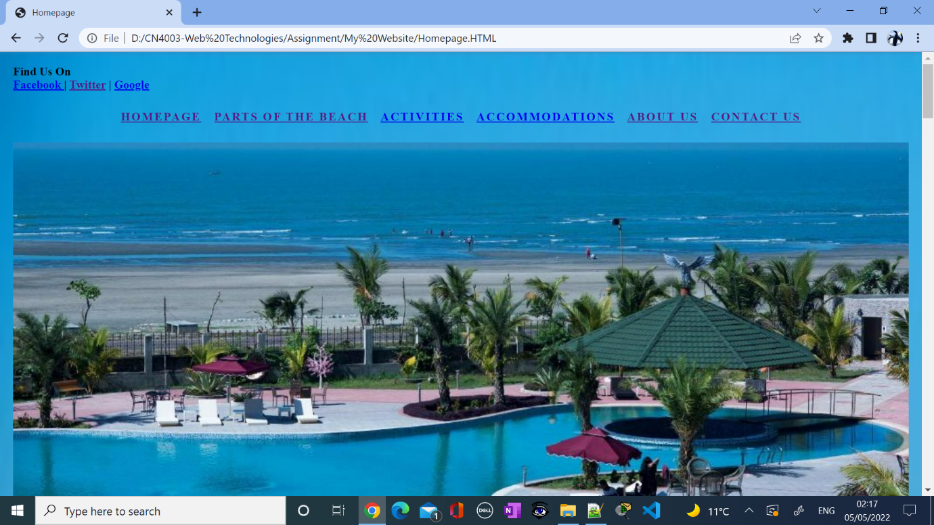

**Course Work-CN4003-Web Technology**

**Project Theme: Relax, Recharge, Rejuvenate**

**Table of Contents……….……………………………………………………………1**

**Task-1: The Case Study……………………………………………………………2-3**

**Task-2: Background Research……………………………………………………3-7**

**Task-3: Page Design**………………………………………………………………7-13

**Task-4: Implementation and Testing**…………………………………………14-27

**Task-5: Evaluation and Reflection……………………………………………27-28**

**References……………………………………………………………………… 28**

**Screenshots of Code……………………………………………………………28-62**

**Task-1: The Case Study**

**Introduction:**

Taking a vacation is better for health which lowers diseases, reduces stress, depression, and anxiety enhances productivity and other life satisfaction. So many people do not appreciate the things that are around them. Some people cannot get away because of budget, partner, or other family members’ schedules. It became even more difficult for pandemic travel restrictions in past years.

**Staycation Idea:**

Promoting staycation as a local business and establishing it in the local community I am planning to build a well-organized website which is my assignment for this module. For that, I have chosen **“Coxes Bazar”** which is the tourism capital of Bangladesh.

**Coxes Bazar in Bangladesh:**

**Cox’s Bazar Beach** is the world’s longest unbroken sandy beach which is situated in Bangladesh. The beach is 120 km long and it slopes gently down to the blue waters of the Bay of Bengal next to the scenic backdrop of a sequence of hills covered with deep green forests. This kind of straight and smooth beach is scarcely seen in any place on the globe. The specialty of **Cox’s Bazar** beach includes miles of golden sands, soaring cliffs, surfing waves, unusual conch shells, and enjoy seafood.

**Aim of the Idea:**

Domestic tourism is presenting less interest compared to the strong support international tourism is receiving.

The aim of the study is-

* To encourage people to consider their budgeting and planning, a staycation is much cheaper than a usual vacation abroad.
* To encourage people to help local businesses stay afloat by spending their valuable vacation.

**Importance:**

The website I will create will be very helpful to overcome such a COVID-19 pandemic situation and will allow users to decide and manage their time for any unexpected situation in the future. There are so many challenges people face and the idea will make significant changes in people’s lives to lower their stress and anxieties.

To do this I have some initial plans to make it more effective.

* Make the website mobile responsive
* Make the site easy to find.
* Make the website easy to navigate.
* Keep the website uncluttered
* Keep the website design simple.
* Focus on the website speed

**Conclusion:**

Now a days, people make their final decision for travel by visiting website. It is important to have a website for every business. A website is the best way to promote staycation as using the internet has increased especially during Covid-19. Availability of the internet to everyone of all ages it becomes easier to access and browse. If the website is accessible via all devices, it benefits the business as well as users.

**Task-2: Background Research:**

I will conduct background research and evaluate 10 similar website which promotes the following features: design, usability, functionality, and legal requirements. I will create a table structure to make it easy to understand.

|  |  |  |  |  |
| --- | --- | --- | --- | --- |
| **Website** | **Design** | **Usability** | **Functionality** | **Legal Requirements** |
| 1. [**https://www.bangladesh.com/travel/vacations/**](https://www.bangladesh.com/travel/vacations/) | The website has minimal background images and some information about staycation and appealing animations through the webpage. It has useful information about staycation resorts that may be useful. | The usability of the webpage allows for swift navigation around the page with a ribbon on top of the page with different categories. | As mentioned above, the design is clear as users can click on each distinct tab that allows the users to access the information that they need. They also have useful information and click on the relevant links on top of the information that is given. | This website has legal requirements, such as copyright information |
| 1. <http://www.bangladeshvacation.com> | The big images of the tourist spot indicate the page.  It makes use of photos displayed on the pages which makes it very much easier for the users to understand. | This website is very easy to use, and all the buttons are very clear and accessible.  There is a clear navigation bar at the top. The page is not overloaded with huge information, and it is easy for the users to navigate. | This website is looking very professional and well organized. There are no adverts on the screen to destruct the user’s attention. | This website needed to post a privacy policy. |
| **3.**  **https://nijhoom.com/** | The design is very appealing it the user as it is clear to read as well as animations are smooth. The page also has some background at the top of the page that makes it stand out. | The user can use a website where there is also a ribbon at the top of the page that allows the user to click on 3 distinct colors. When each tab is clicked on, there is an animation that | Because the design is clear, users can click on each distinct tab that allows users to access the information that they need. | This website has legal requirements, such as copyright information |
| **4.**  **https://www.responsiblevacation.com/copy/about-us** | The design of the website is well done and dynamic with animations, information given and images that allows users to click on that takes them to another link. | On the website there are a variety of tabs that are on the top right of the page. users can click on embedded links to which leads to other pages. However, at the top left with images that have links embedded throughout the website. | The website is easily accessible as people with visual disabilities can more readily click on the relevant tabs.  The website also has clear text so that all users can read. | This website clearly has a privacy policy that is stated by law. |
| **5.**  **https://jetliatravels.com/blog/Top-10-Places-to-Visit-in-Bangladesh#** | We can see all the essential information are on the page screen and easily accessible to the other pages, | The website is very easy and suitable for all ages as it does not have advanced English | The buttons worked smoothly, and the page worked efficiently**.** | This website needs a privacy policy. |
| 6.  **<https://mybangla24.com/best-things-to-do-in-coxs-bazar>** | The design of the website is well done and dynamic with animations, the information given, and images that allow users to click on that take them to another link. | On the website, there are a variety of tabs that are on the top right of the page. users can click on embedded links that lead to other pages. However, at the top left with images that have links embedded throughout the website. | The website is easily accessible as people with visual disabilities can more readily click on the relevant tabs.  The website also has clear text so that all users can read it. | This website clearly has a privacy policy that is stated by law. |
| 7. **<https://www.tripadvisor.co.uk/Tourism-g667467-Cox_s_Bazar_Chittagong_Division-Vacations.html>** | On the landing screen of this website can see a green and black color scheme logo. All the necessary information is displayed on the screen and easily accessible. Responsive images make the website more attractive for the users to browse it. | The website is very easy to use step by step although there was an advertisement on the page. | The website looks very professional as it is designed. I have opened this website with the most indifferent browsers and it works very smoothly. | This website clearly has a privacy policy that is stated by law |
| 8.  https://www.responsiblevacation.com/vacation/4948/bangladesh-vacation | The website has a clear white and green color scheme when you open it. Then another page has its own color scheme based on the information described. All the page information was distributed nicely. | This website is very easy to use. With a very clear navigation bar at the top, you take smoothly to the page you want to go. | It is a very professional and well-organized website. There is no advertisement on the site to destruct users’ attraction. | The website has a clear privacy policy. |
| **9.**  **https://nomadparadise.com/places-to-visit-in-bangladesh/** | This website is a participant in the Amazon Services LLC Program, an affiliate advertising program designed to provide means for sites to earn advertising fees by advertising and linking to Amazon.com. | The usability is very efficient as there is a form to enter your details and search your area. | Because the design is clear, users can click on each distinct tab that allows users to access the information that they need. The background is suited to the text so that the user can click on the relevant tabs. | This website has a clear privacy policy. |
| 10.  **<https://championtraveler.com/dates/best-time-to-visit-cox-s-bazar-bd/>** | The design is average with minimal backgrounds and some colorful images. | The design of the website is good with minimal background pictures on the page. There are no adverts to destruct user’s attention to access when they browse it. | Because the design is clear, users can click on each distinct tab that allows users to access the information that they need. Users have a form on the contact page to fill out such as stays, check-in-check-out, and click on find. | This website has legal requirements, such as copyright information. |
|  |  |  |  |  |

**Summary:**

The research of the above websites has given me a clear understanding of building a better website. All these websites provide an insight into the design, usability, functionality, and legal requirements of the website. The common theme of most websites has a clean and tidy background and own distinct colors related to the topic. All of them have useful information related to the topic and images make it clear about its history. Clear links and information are provided throughout all the websites with navigation bars made it more clear to users. Some of the websites focused on their business instead of focusing on and promoting staycation which will disappoint users to visit and engage more with it. Therefore, websites must have a more professional and dynamic aspect that will allow users to be more engaged.

Click [http://www.draw.io](http://www.draw.io/) link to open resource.

**Task-3: Page Design:**

**Home Page:**

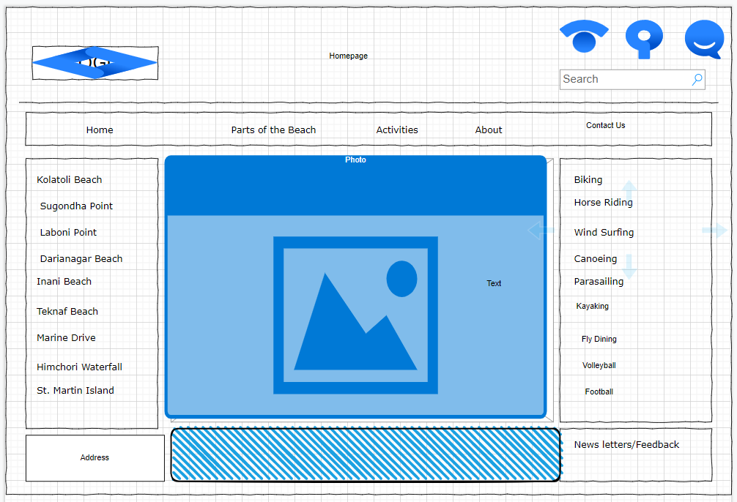

**Parts of the Beach Page:**

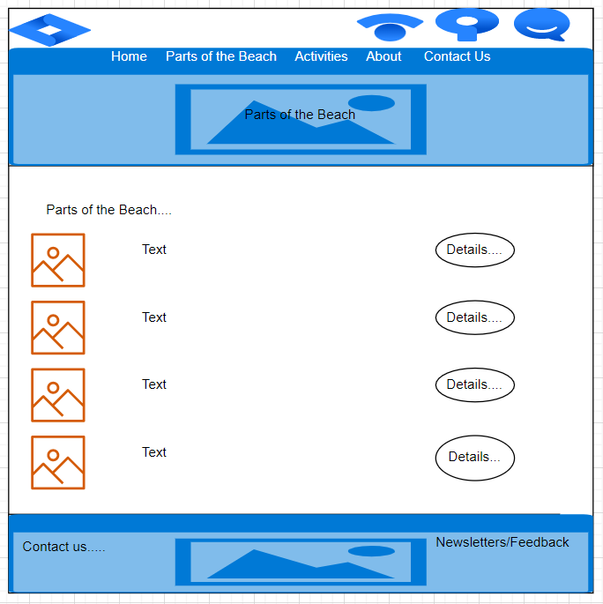

**Activities Page:**

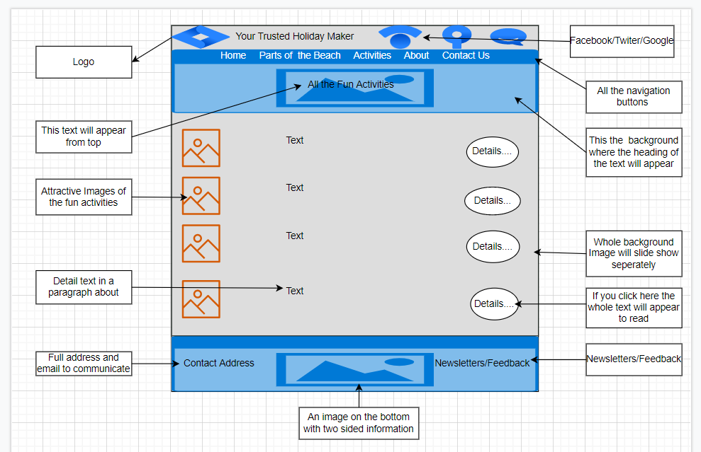

**Accommodation Page:**

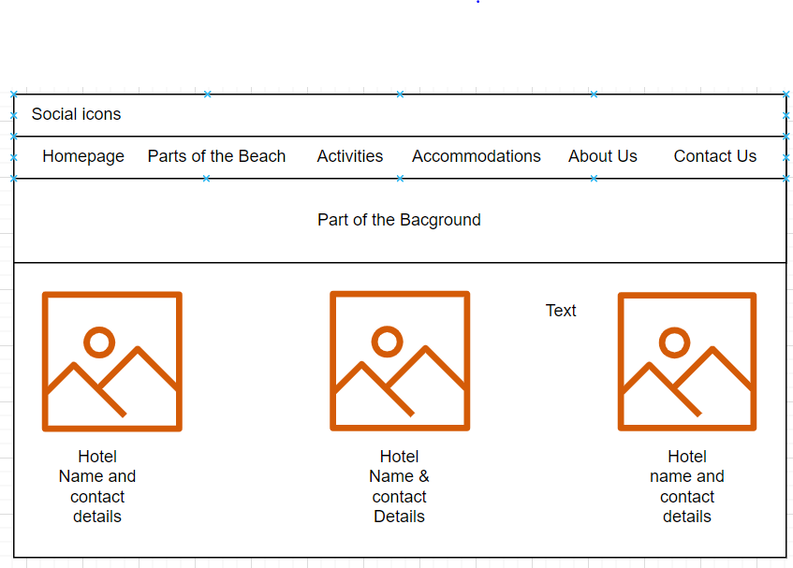

**About Page:**

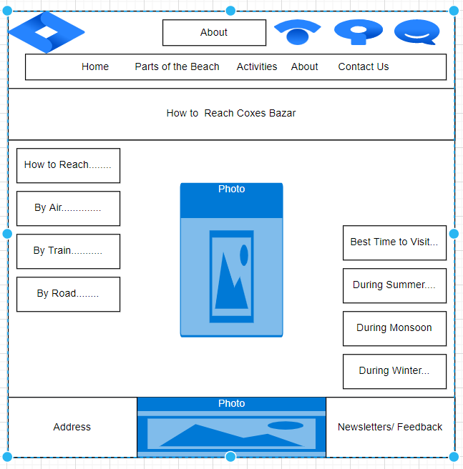

**Contact Us Page:**

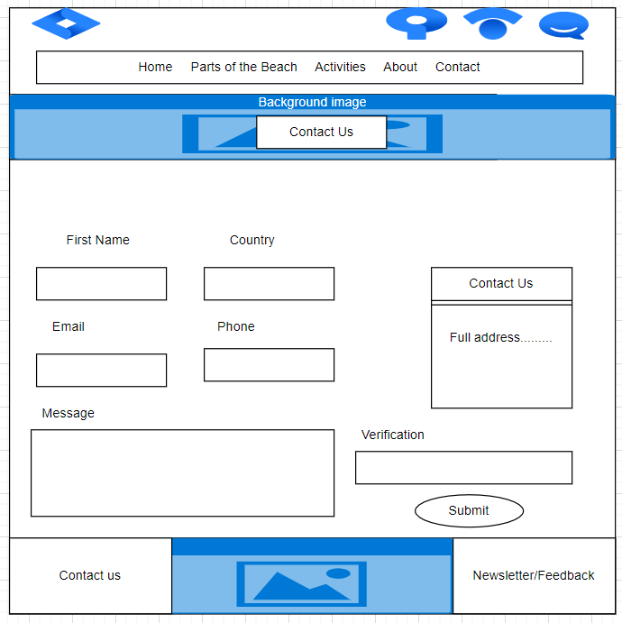

I

**Navigation of the Webpage:**

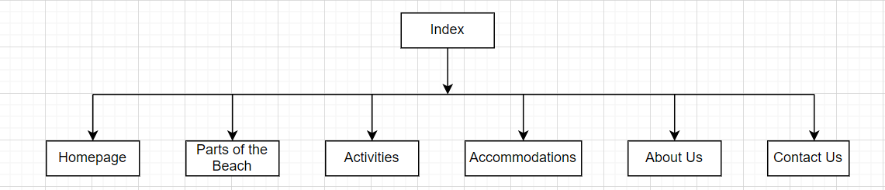

I have decided to use a flat structure approach without the sub-layer’s navigation bar. I believe it will be the greatest method to use as it will be much simpler.

**Colour Scheme**:

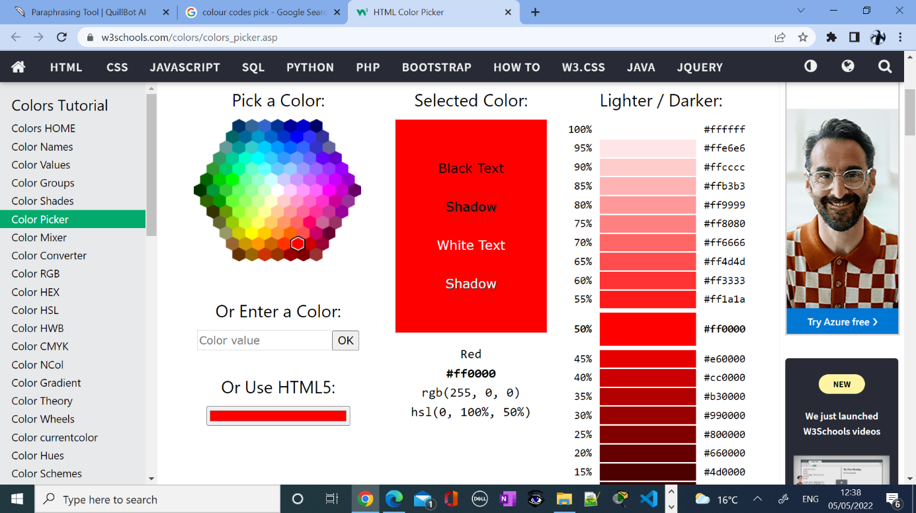

**Background Colour**:

I will use background colours similar to this one shown above, because it matches with my topic and its theme as my staycation is about sea beach and bright enough to passes the message to the users and will help to promote and stand out with other colours of my webpage.

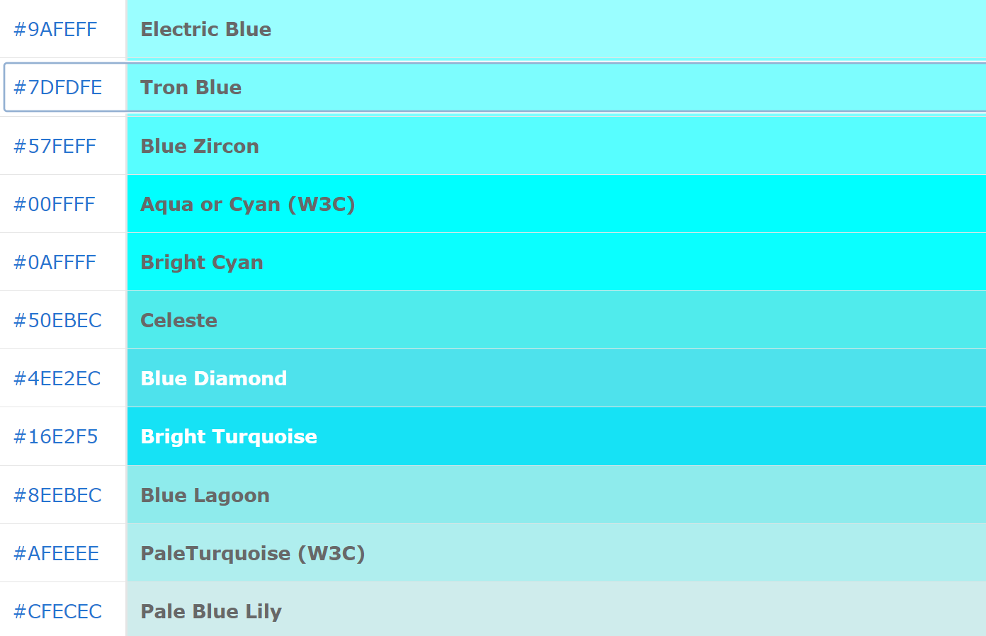

**Header:**

Every page of my website has different images, and I will match my background with those images and keep the theme similar. Most of my font is the black colour for the will make the pages stand out from the backgrounds. As my staycation theme is related to the beach environment and most of the background will be reflected in blue with the theme of my page.



**Forms & Boxes:**

Consistency with the colour theme throughout every page is very important. I will use torn-blue or keep it normal white colour for the different forms, tables, and boxes.



**Overview:**

There is some main component of a great web page such as web strategy, search engine optimization, user experience, stylistic message, content and goal achievement. It is important to identify the vision and purpose or goals for a website before built.

I will build my website using a flexible approach, one page at a time. I will start with the homepage. I will follow the instructions and apply the formative feedback to build a useful website.

When designing a website there are a lot of aspects that are more important than the others. Some of these aspects are white space, colour, navigation, positioning and usability. Easy navigation is one of the most important aspect. Navigation on a website refers to how the menu is set up and how the viewer finds where they need to go. One of the most frustrating things is being on a website and not being able to figure out where to go. This can be because the information is too congested, or that it is simply not labelled well or hard to find.

I will use HTML which is the main and important tools for a website design to display the framework and the content of the page, and CSS for the design and interactivity element. The separation of HTML from CSS makes it easier to maintain sites, share style sheets across pages, and tailor pages to different environments. JavaScript could have been used for making the website more attractive.

I will make the URL as simple as possible so that it is relevant as possible, making it easier for users to remember.

So, these are the tools and techniques that I used for the creation of my website

**Task-4:**

**Implementation & Testing:**

**Homepage:**

In the first section of the homepage displays the title of the page and the navigation bar consists of its elements. It is clear to see that each link leads user to go to right page.



In this section top with the heading there is a brief explanation about the staycation.

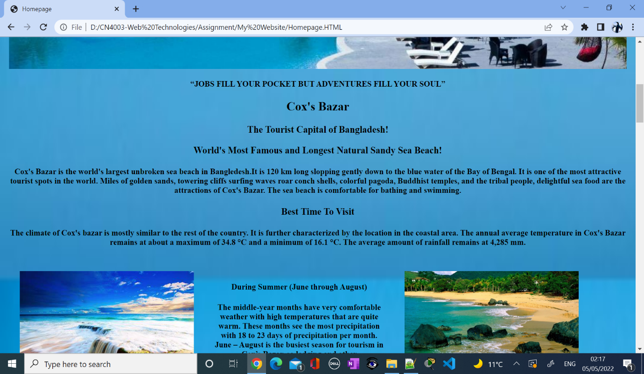

In this section information about the time of the staycation heading and under explain details with images.

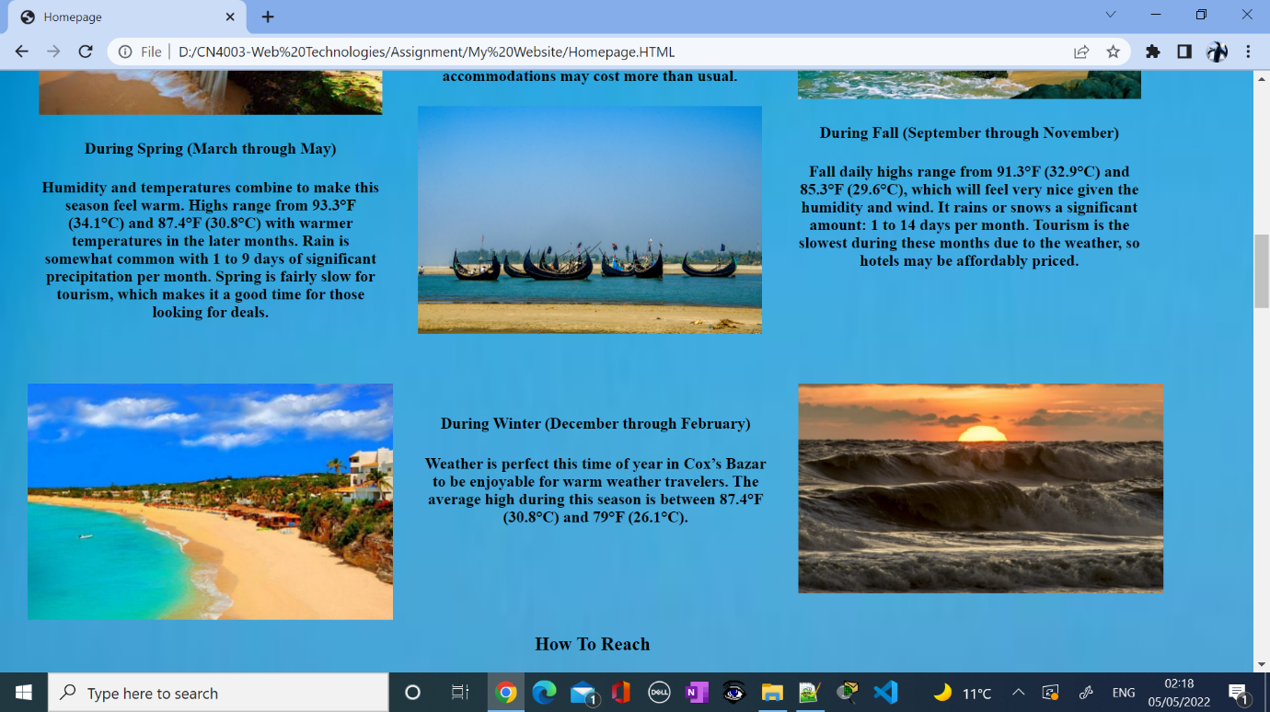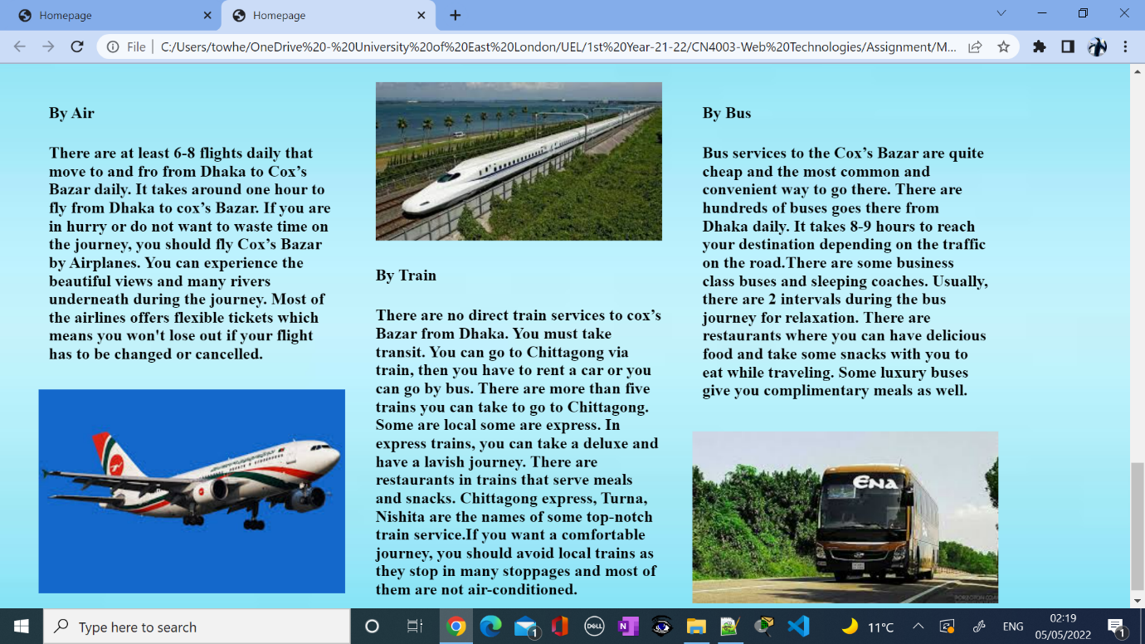

On the page, I created easy-to-read and understand the steps by step instructions on how to reach the destination. I tried to give a clear overview to the users to decide on their staycation by writing details in each section.

**Homepage W3C Report:**

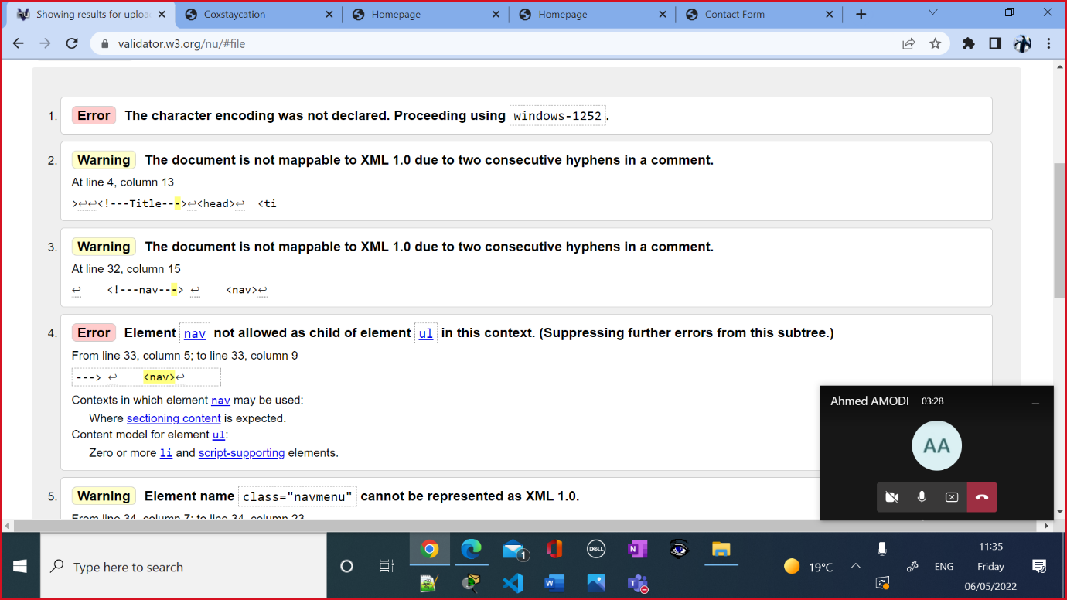

**Parts of the Beach:**

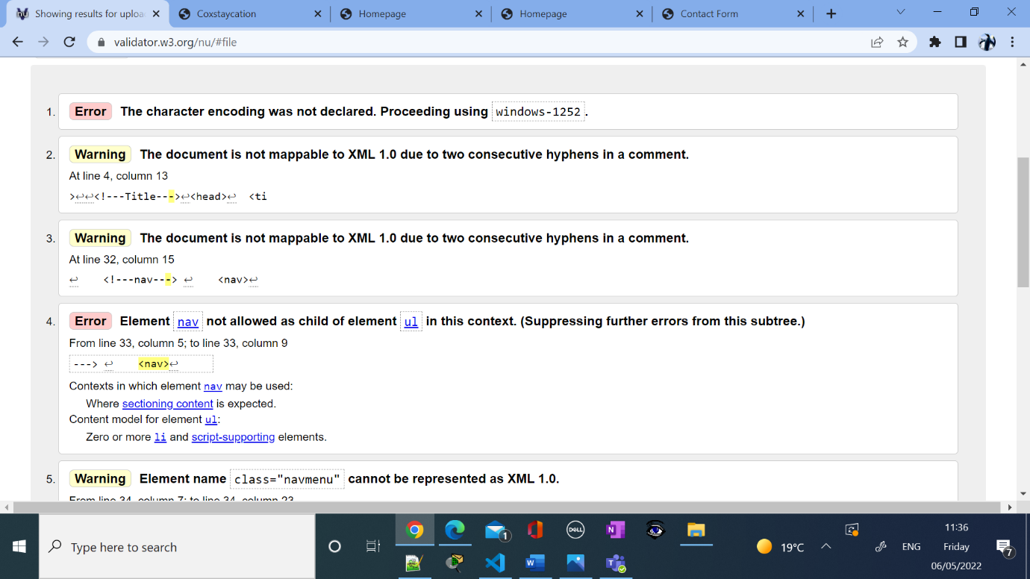

**Activity:**

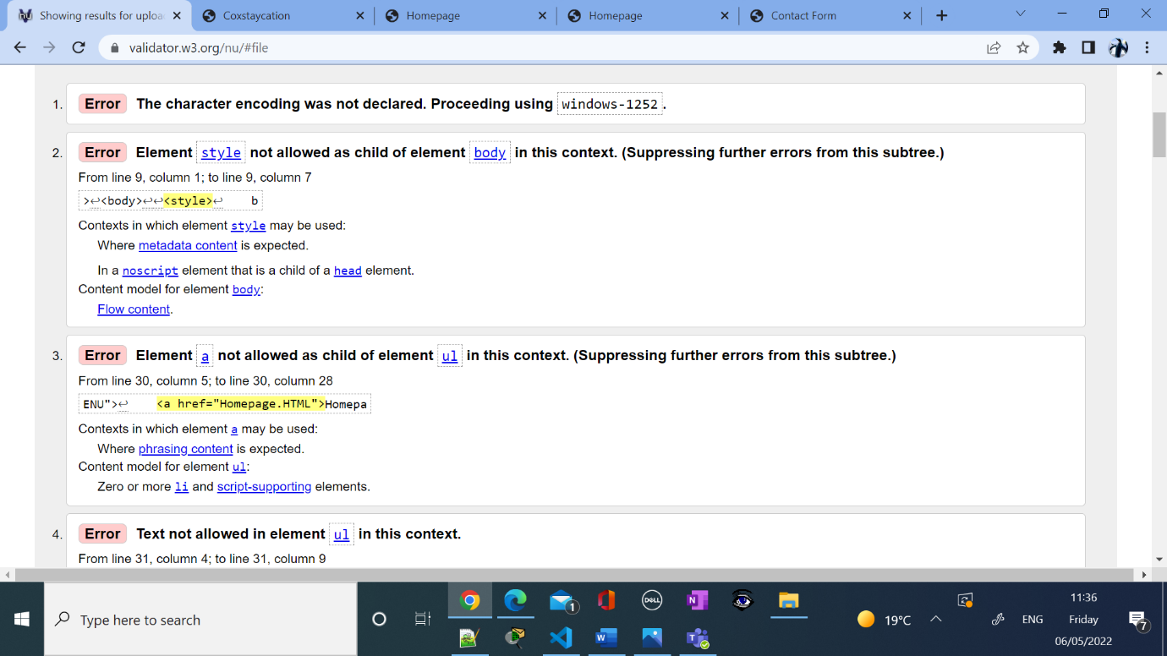

**Accommodation:**

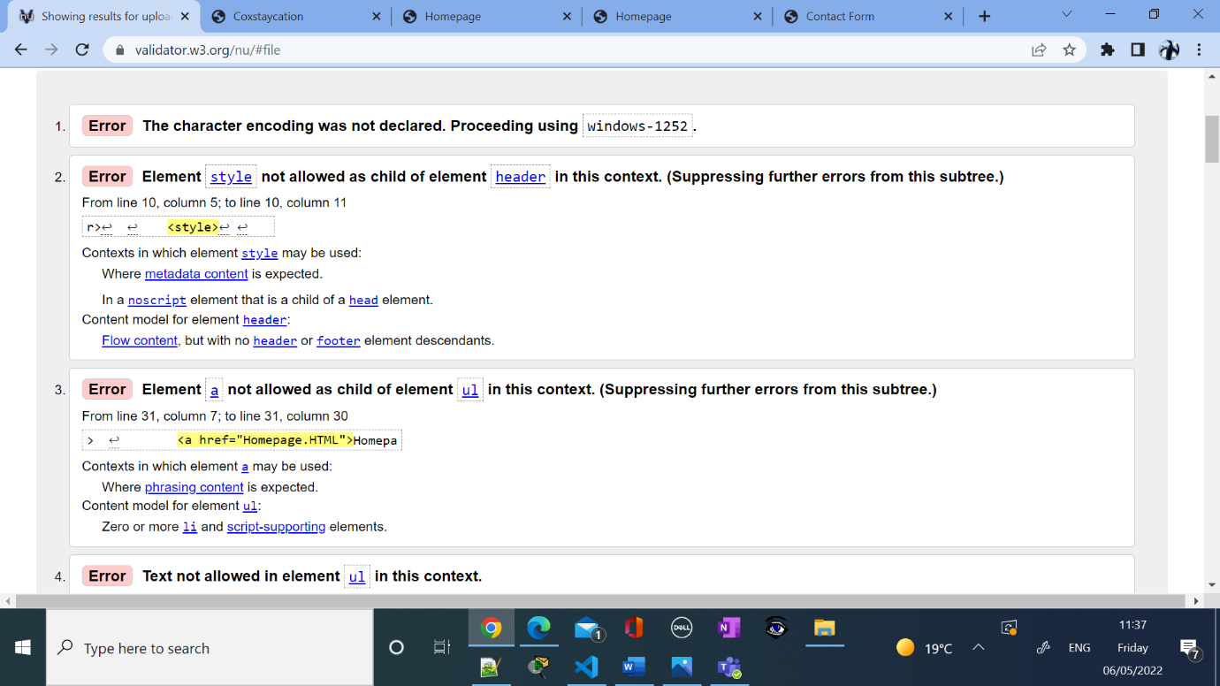

**About Us:**

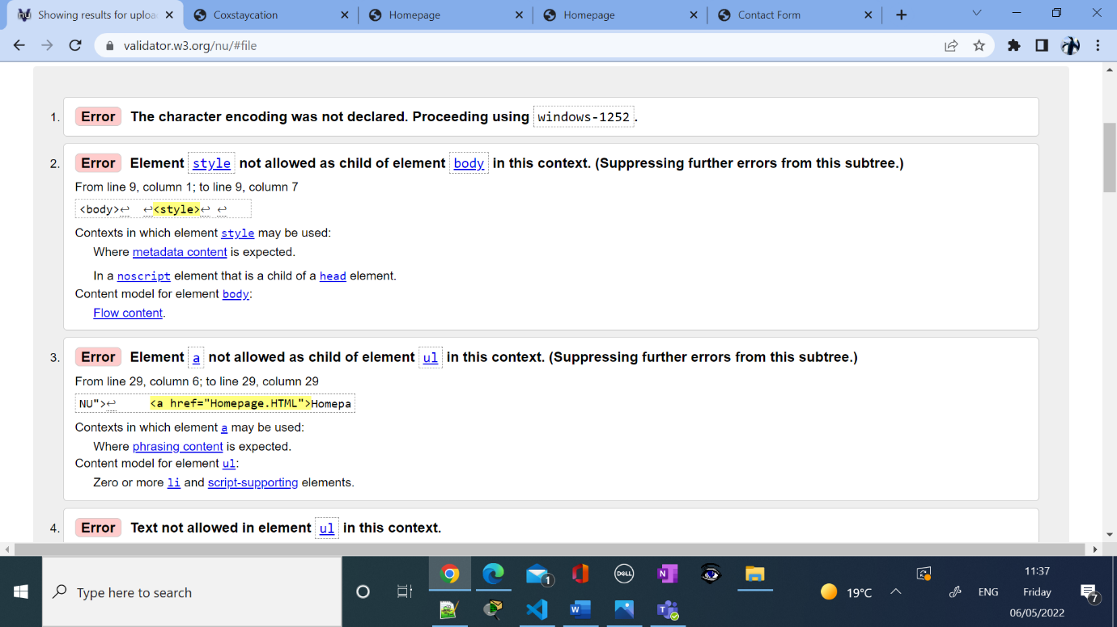

**Contact Us:**

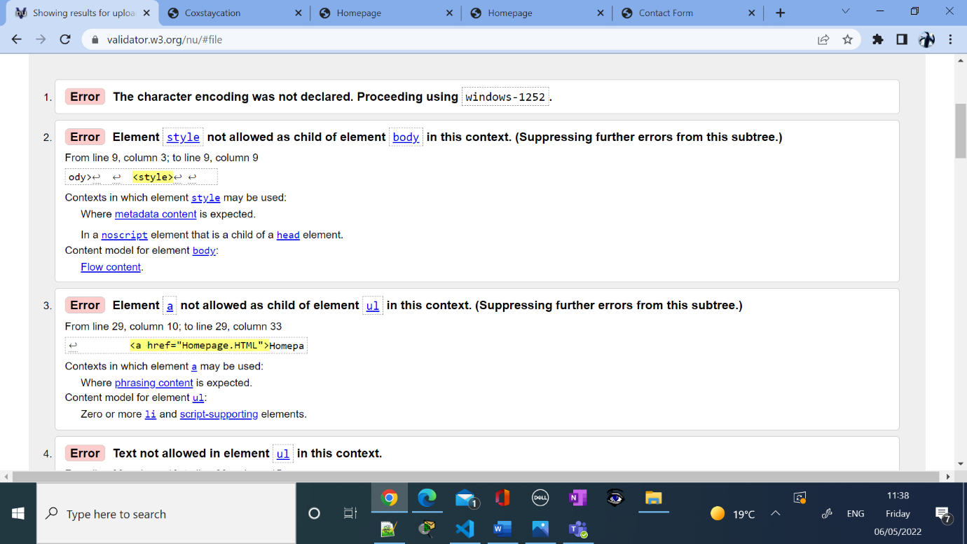

**Contact Us Form:**

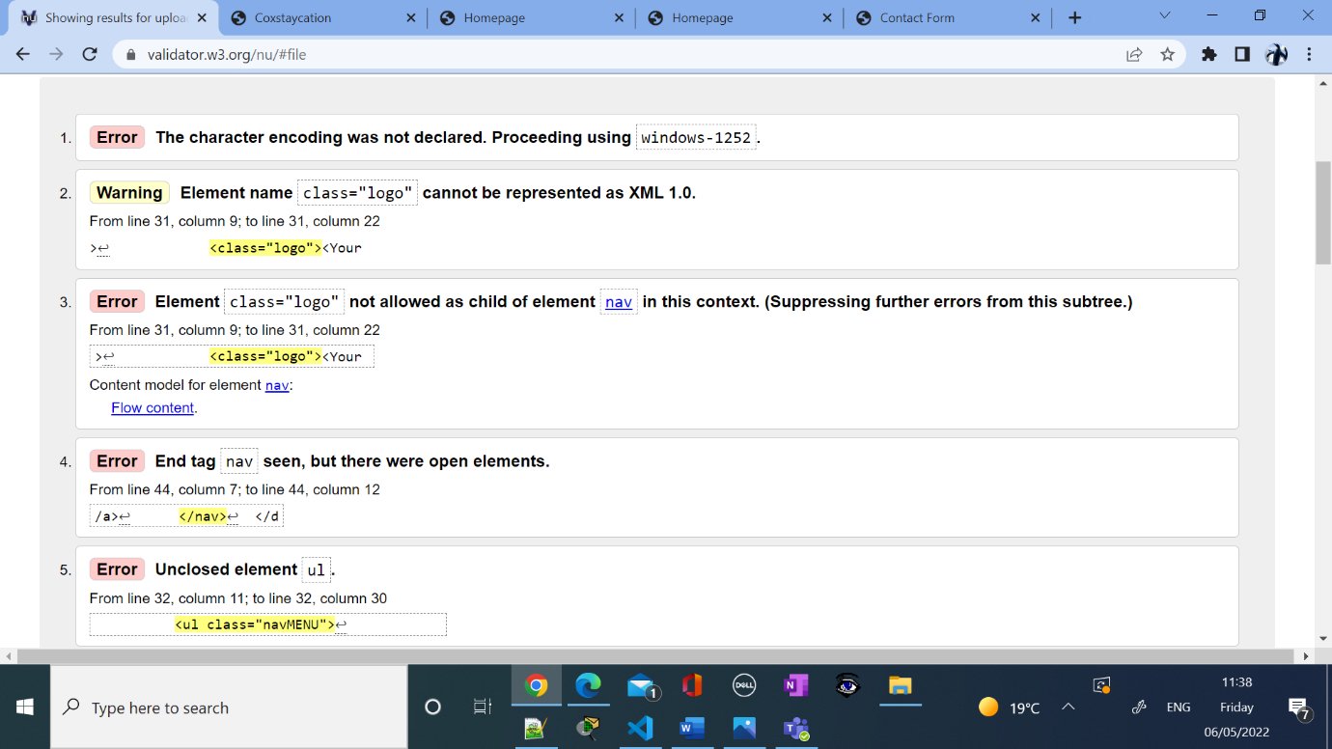

**Parts of the Beach:**

On the second page with the h3 heading make the attention to the user to go through the details of the next step.

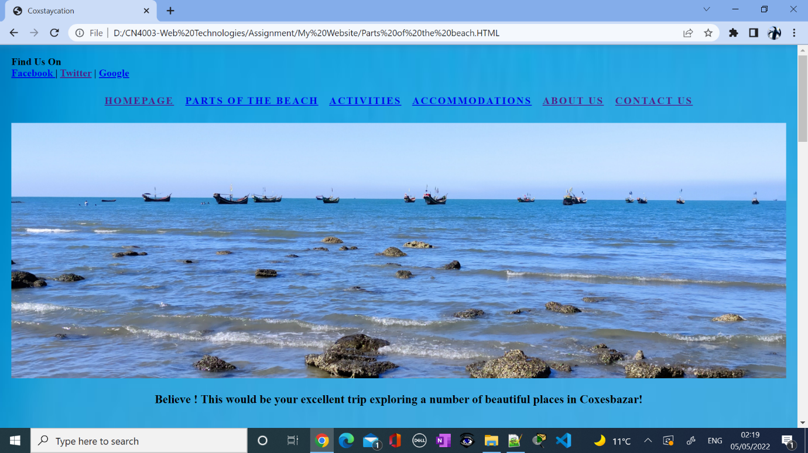

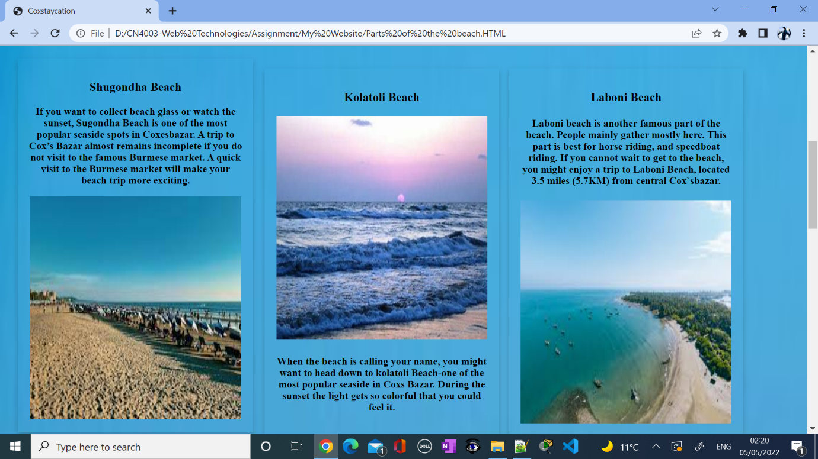

In this section of the page with h4 text I explained about the specific attraction of the staycation to attract user to take their decision about it.

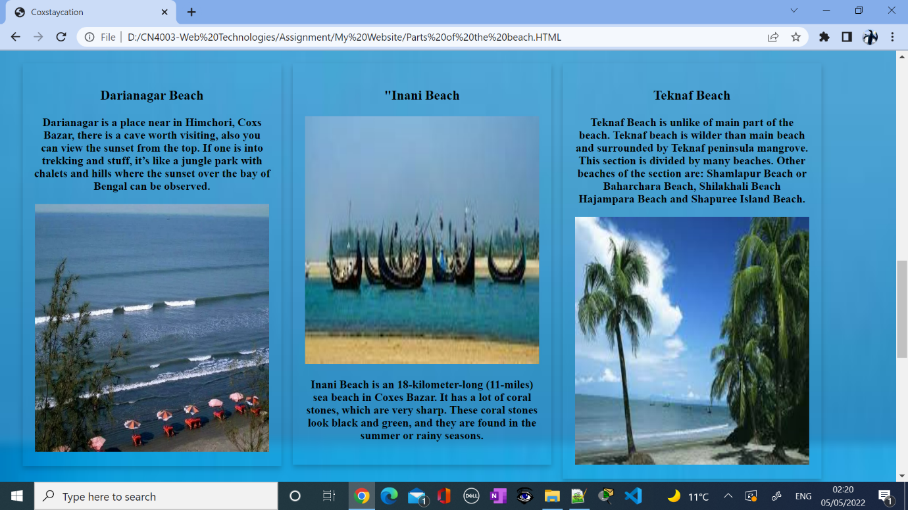

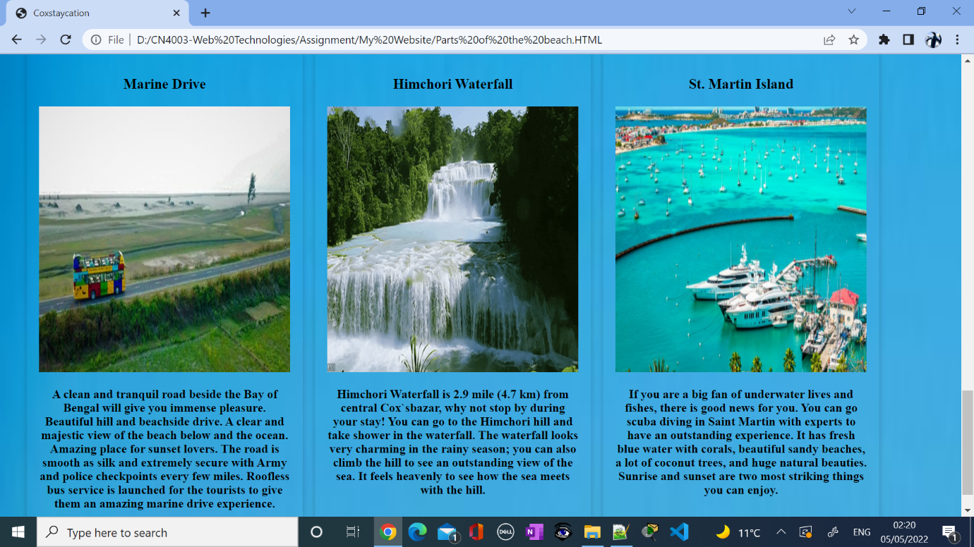

**Activities Page:**

On this page, users will find a clear idea about the activities during their staycation.

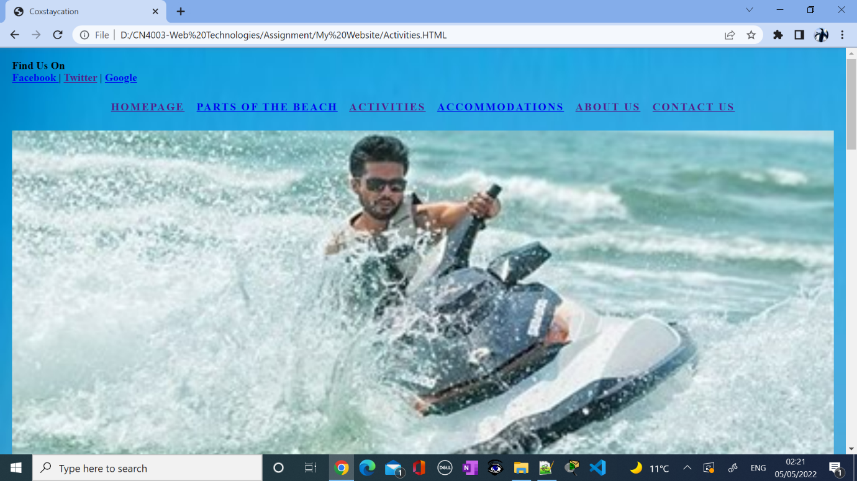

As I use the same design of this page this page gives users an insight into the activities during their tour. The page is simple with an effective layout.

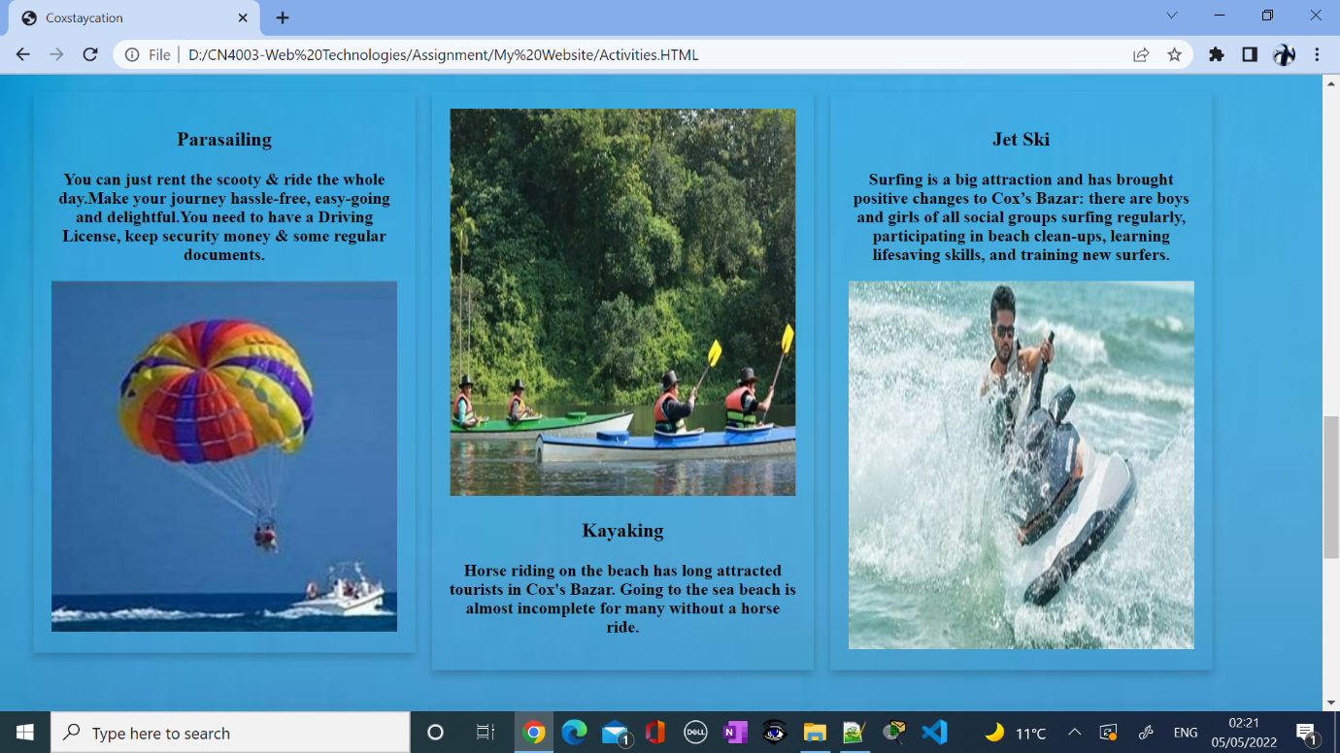

**Accommodation Page:**

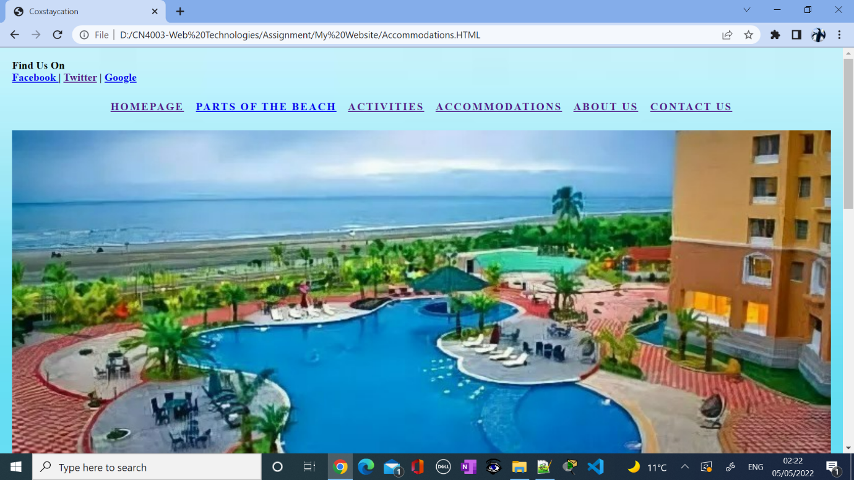

This is the image of Coxes Bazar Beach and the background of the page and the black text inside the designed card act as a contrast. The contrast and image reinforce the theme of the staycation.

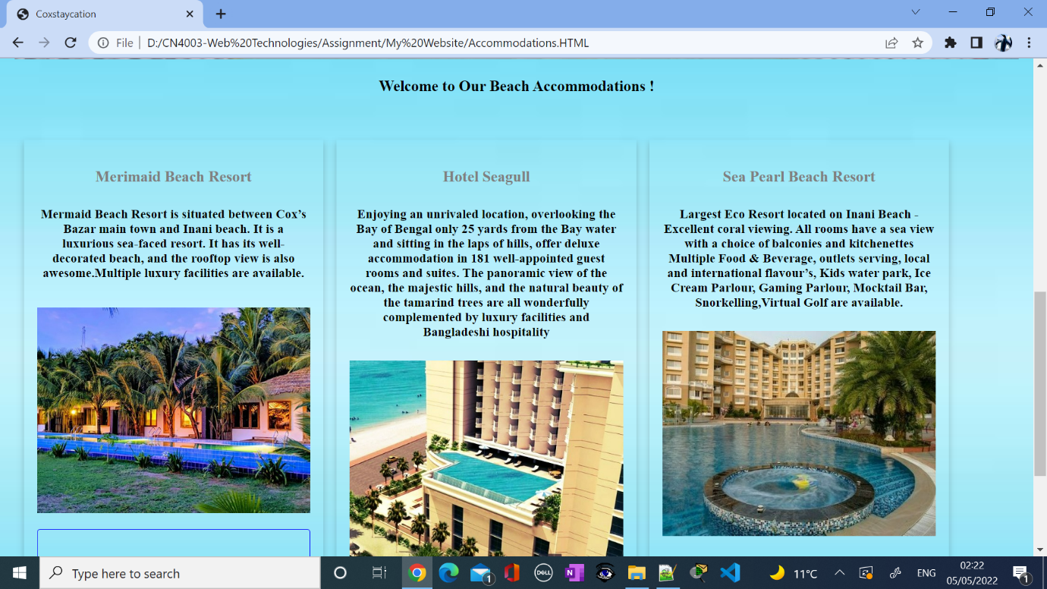

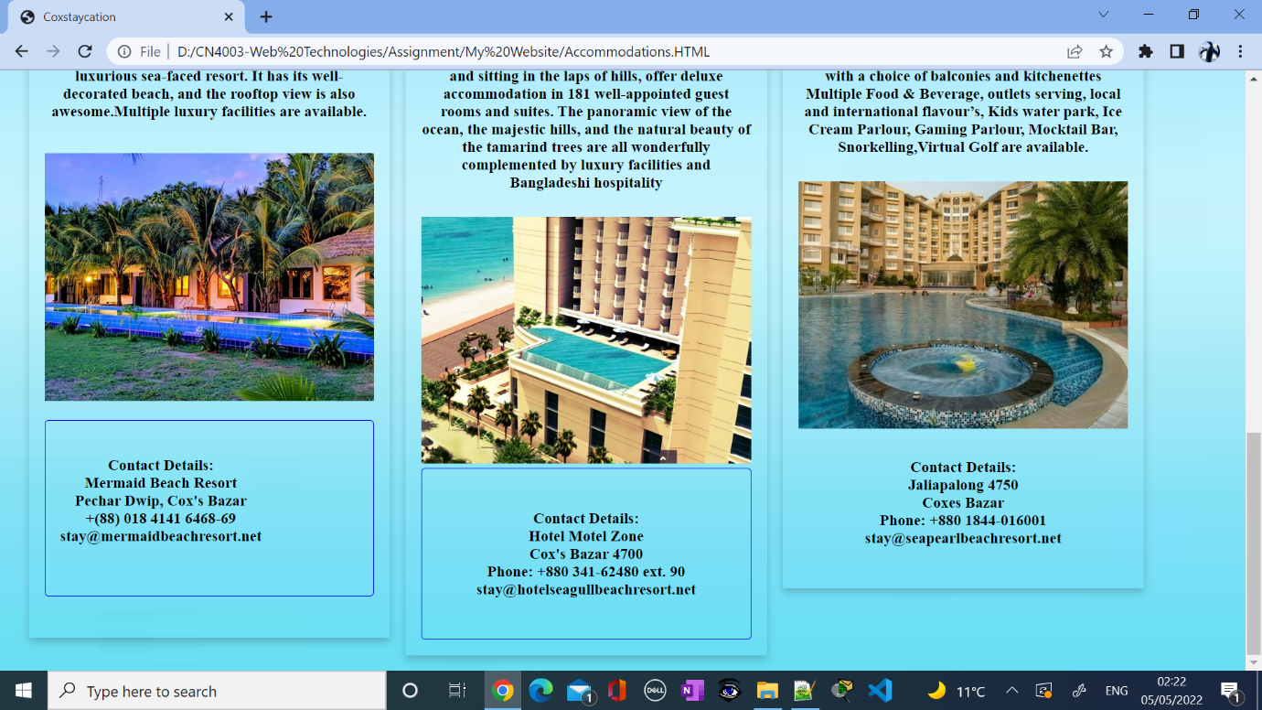

**About Us Page:**

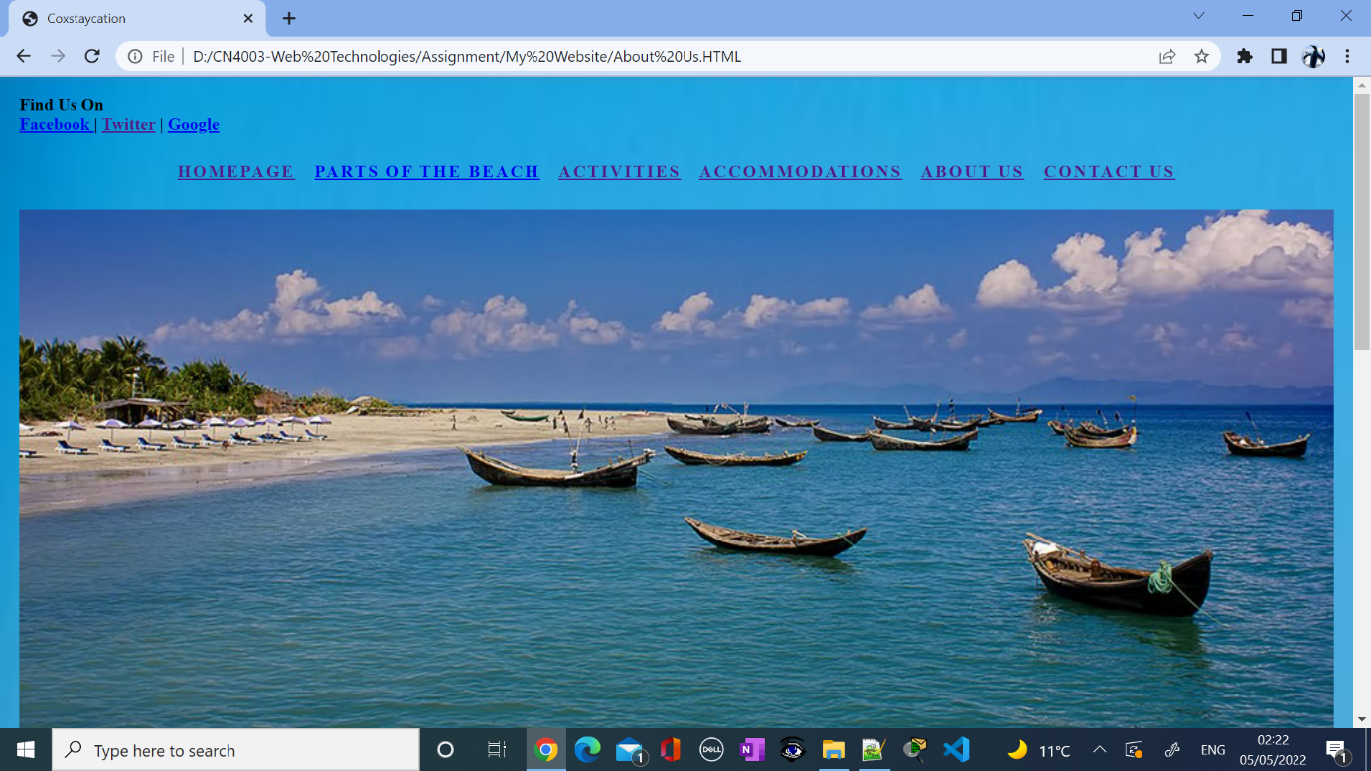

This page tells users about their whole journey and the process. It is explained clearly about the company and its vision and mission. It is also a simple page but with an effective layout.

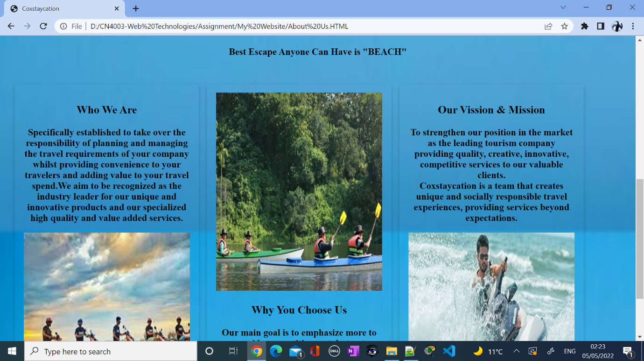

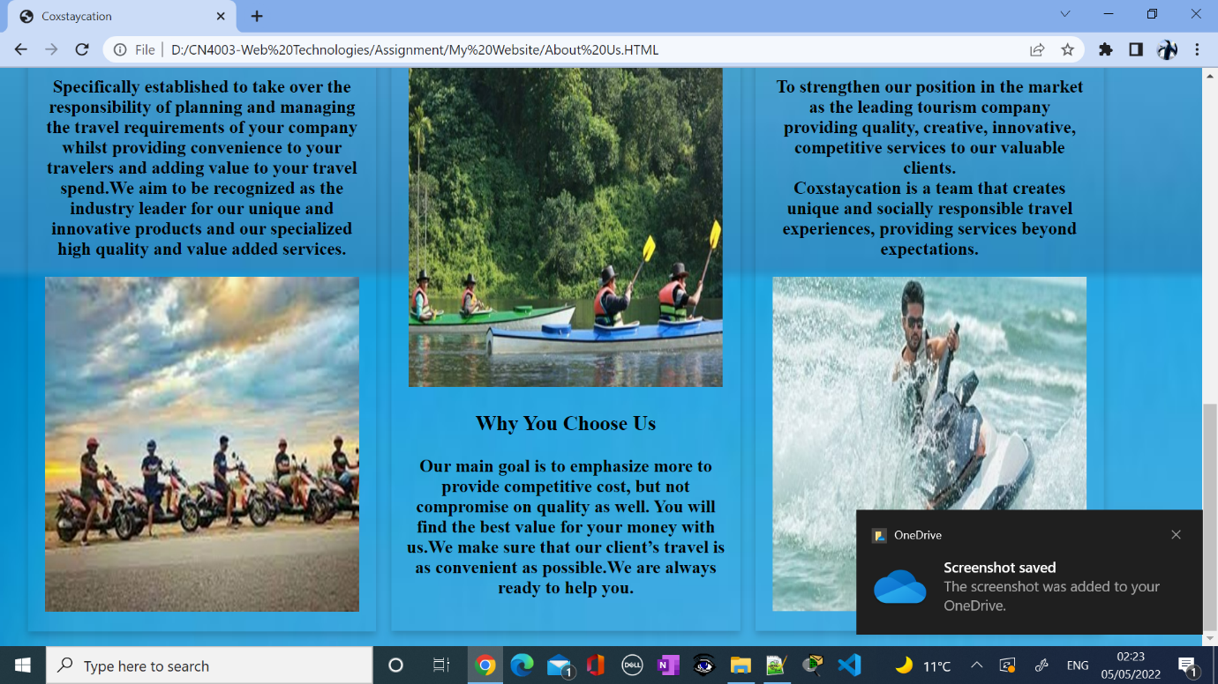

**Contact Page:**

This is the contact page which contains the address, email address, contact number and an inquiry form to communicate.

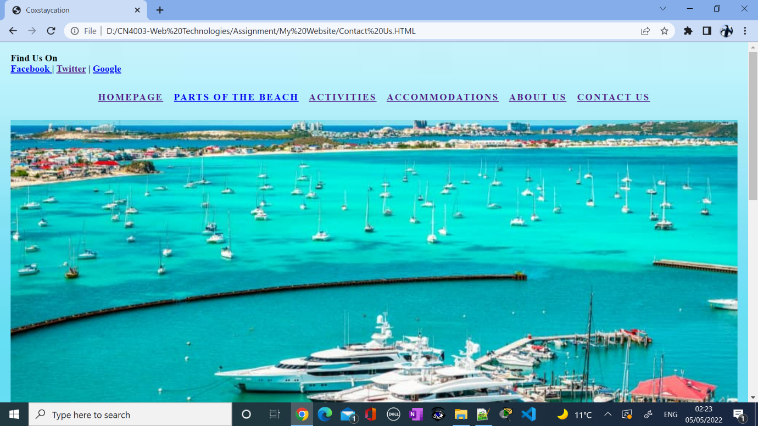

This page has a dynamic background and image.

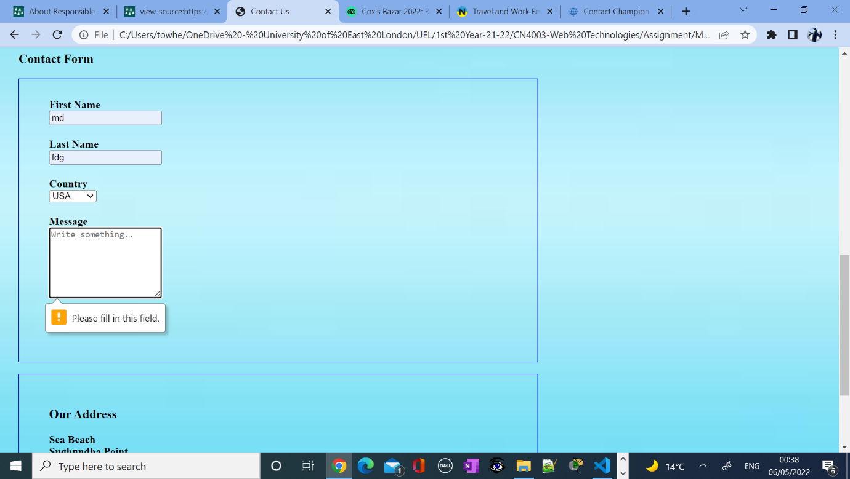

In this section shows when all the boxes not filled and shows the errors

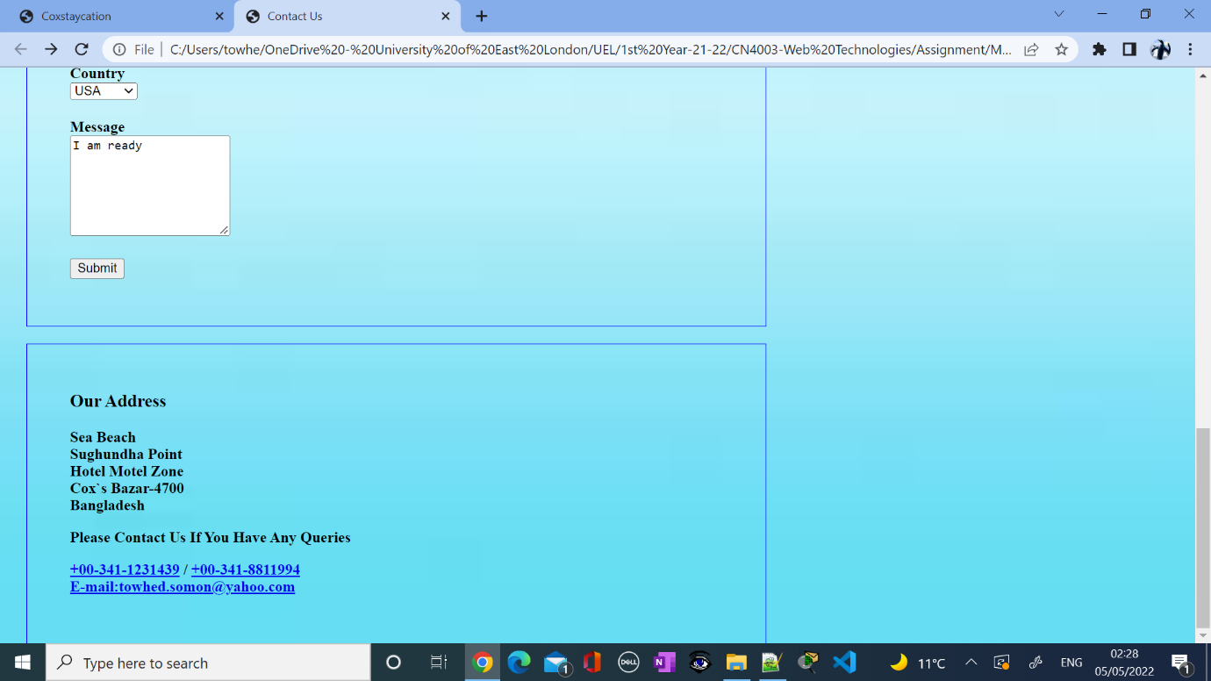

This section of the page shows correct information has been filled and at the bottom is a confirmation message to the users.

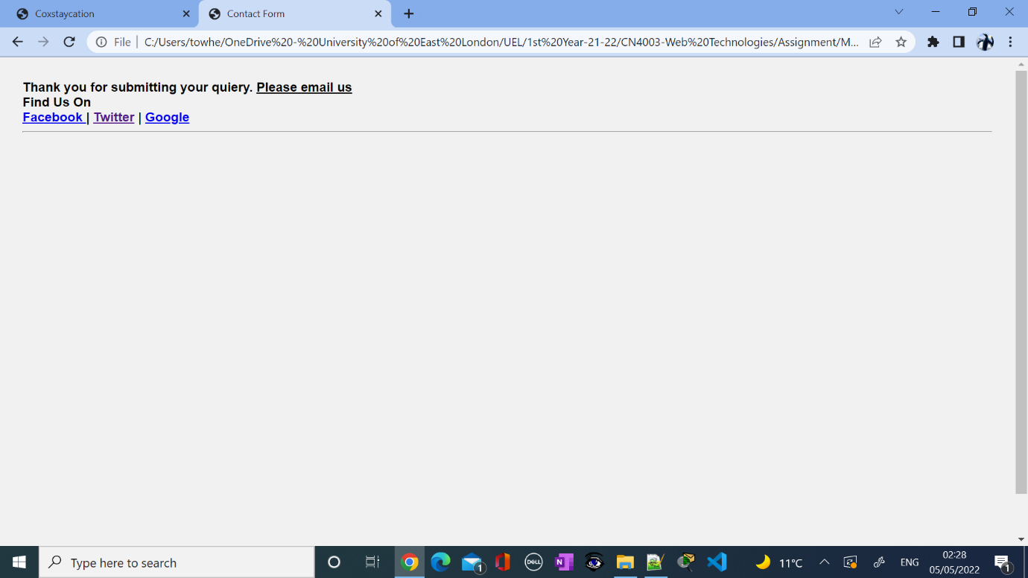

**Task-5:**

**Evaluation and Reflection:**

The popularity of this kind of website is high because it is not only designed for a specific target audience but for people of all age groups. This is an informative business website. The website that I designed I think is very effective and helpful in terms of promoting staycation as a business and considering it as a usual vacation idea. Looking back at the research conducted in Task 2, I have taken key principles and ideas from the best websites to build my website. My website is easy to navigate for the users. A balance of text and design is present on the website.

**Mobile Accessibility:**

Nowadays almost every person navigates various websites by mobile phone. So, it is very important to make the website mobile responsive.

**Advertising Revenues:**

Advertising through Google Ads could be the best way but is expensive. It is costly as well if want to advertise through another website. As this is an initiative to encourage users and local people as a business it would be easy to advertise via social media like Facebook, Instagram, twitter etc. now a days people from 16-70 are very active on social media.

Promoting through a billboards or poster could be effective way at the bus stops, cinema halls and in the local shops.

**References:**

1. [**https://championtraveler.com/dates/best-time-to-visit-cox-s-bazar-bd/**](https://championtraveler.com/dates/best-time-to-visit-cox-s-bazar-bd/)
2. [**https://nomadparadise.com/places-to-visit-in-bangladesh/**](https://nomadparadise.com/places-to-visit-in-bangladesh/)
3. <https://www.responsiblevacation.com/vacation/4948/bangladesh-vacation>
4. [**https://www.tripadvisor.co.uk/Tourism-g667467-Cox_s_Bazar_Chittagong_Division-Vacations.html**](https://www.tripadvisor.co.uk/Tourism-g667467-Cox_s_Bazar_Chittagong_Division-Vacations.html)
5. [**https://mybangla24.com/best-things-to-do-in-coxs-bazar**](https://mybangla24.com/best-things-to-do-in-coxs-bazar)

**Screenshots of Homepage:**



**Screenshots of the Homepage Codes:**

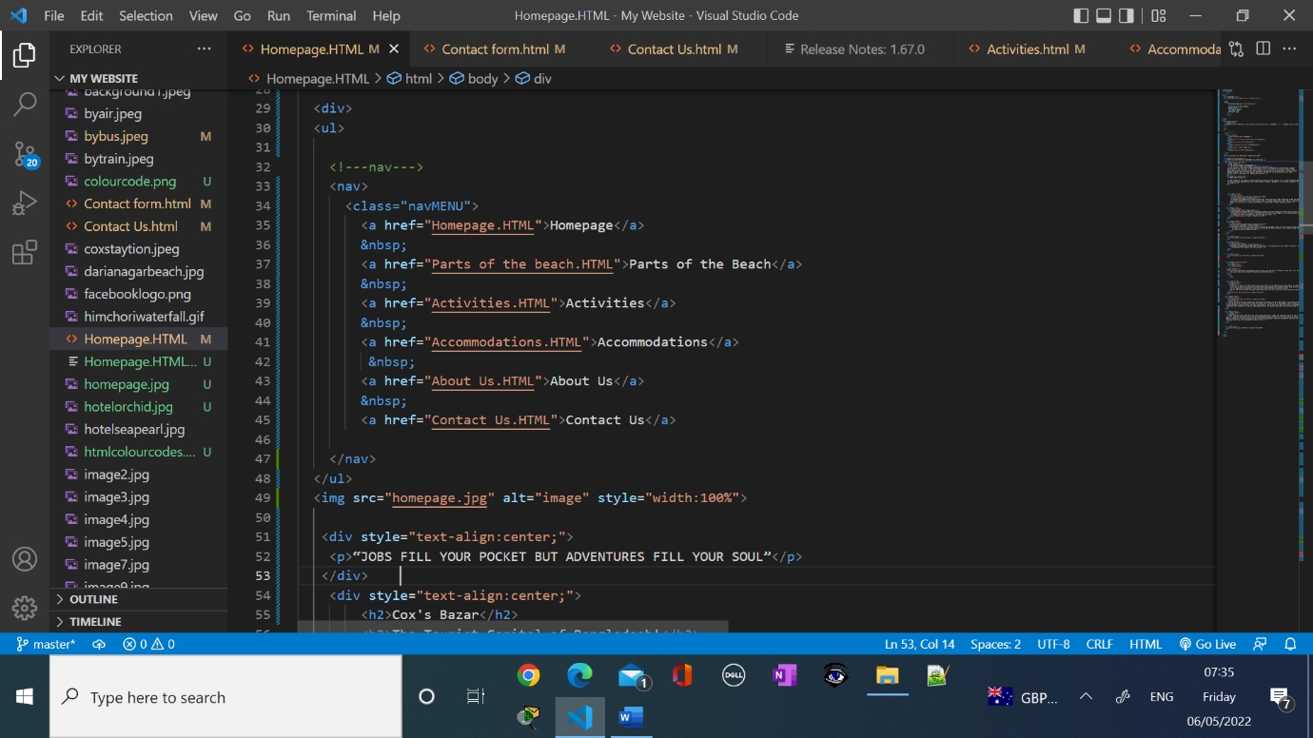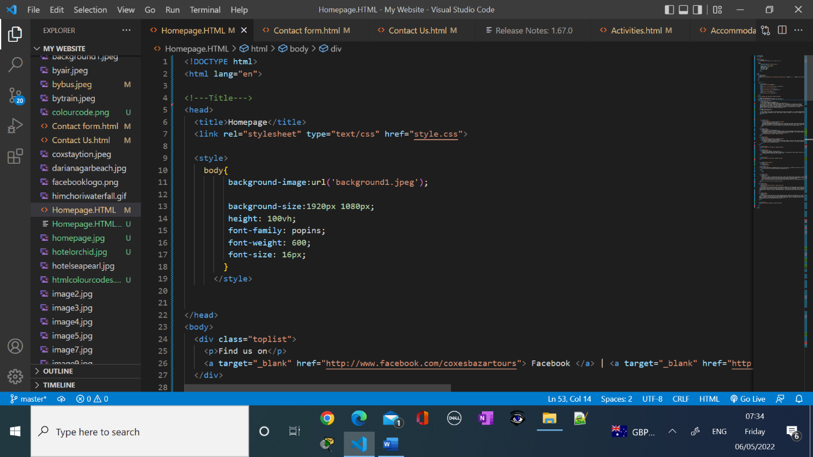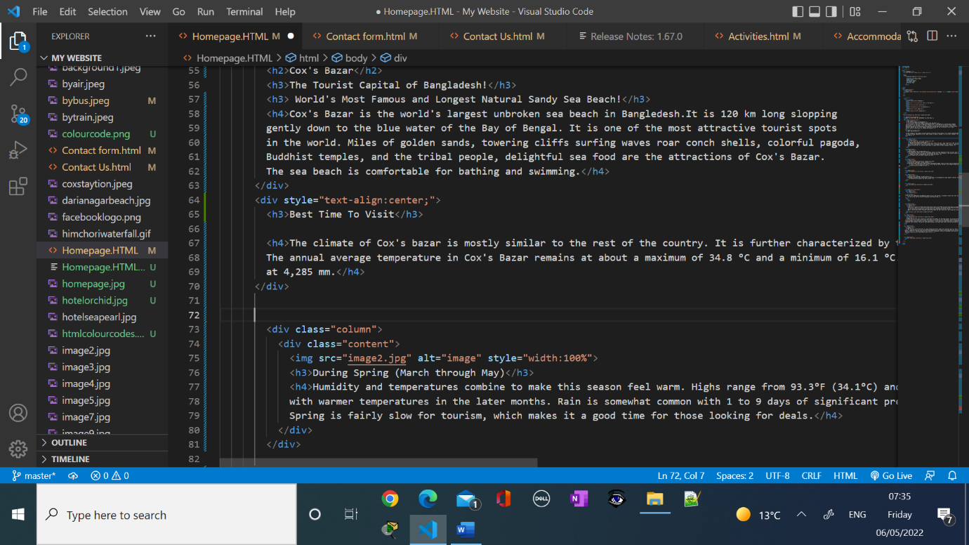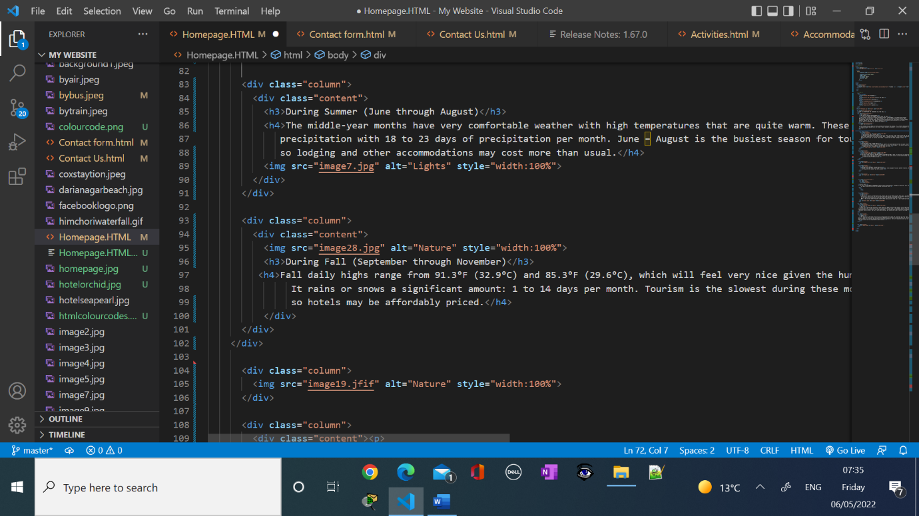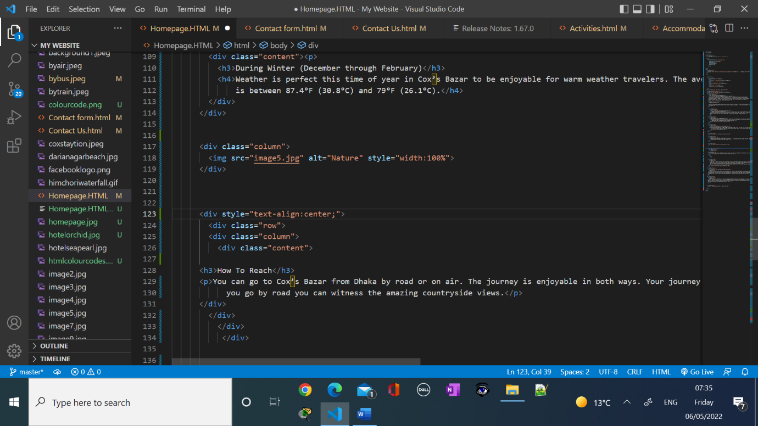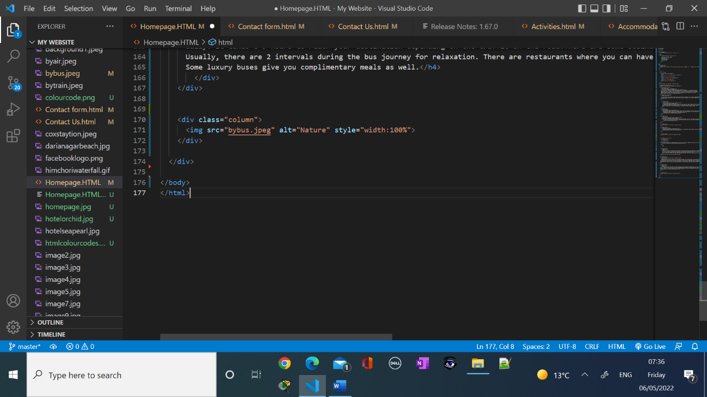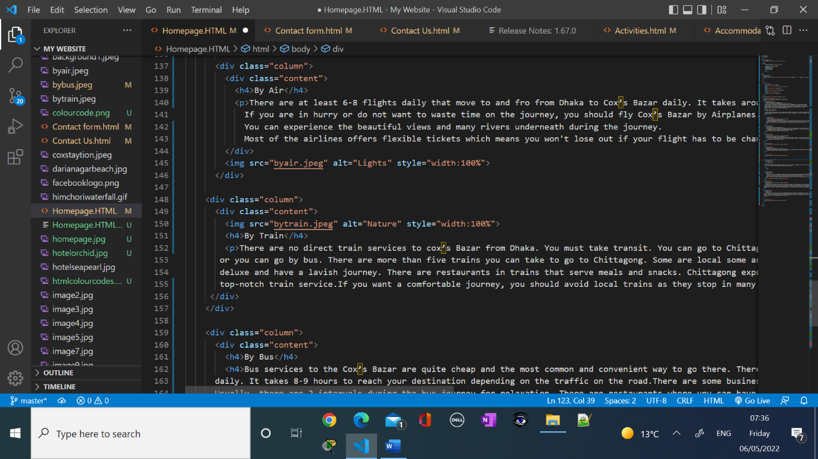

**Screenshots of Parts of the Beach:**



**Screenshots of the Parts of the Beach Codes:**

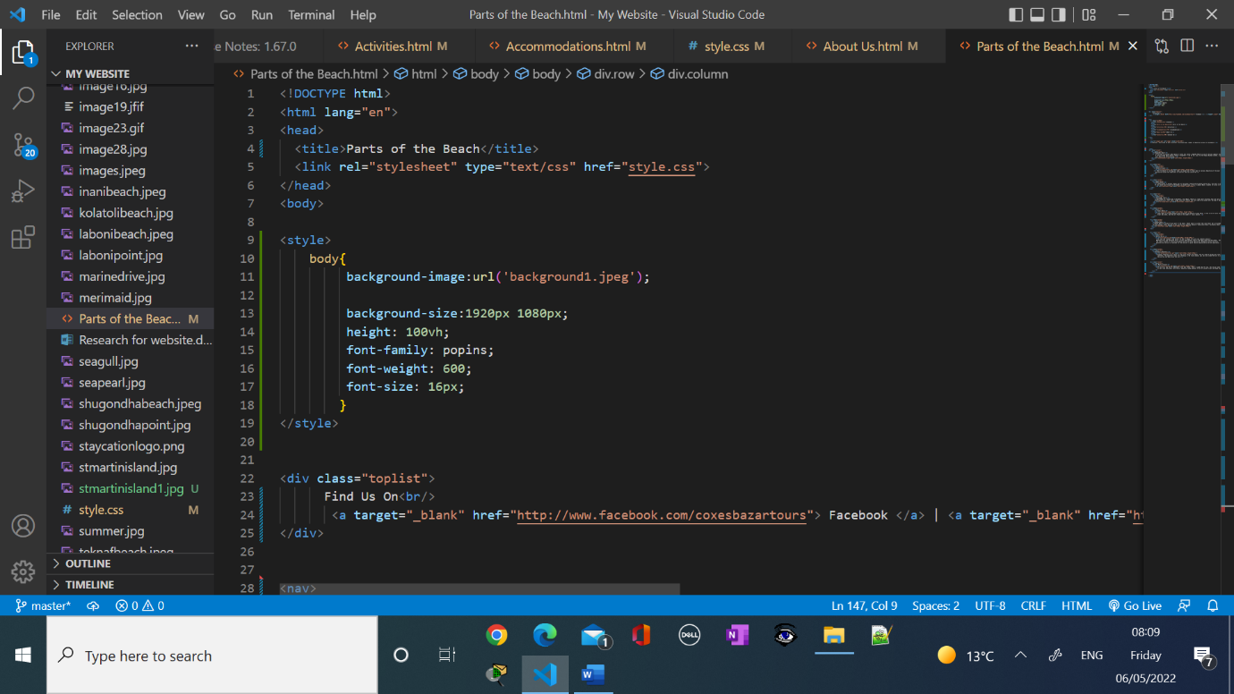

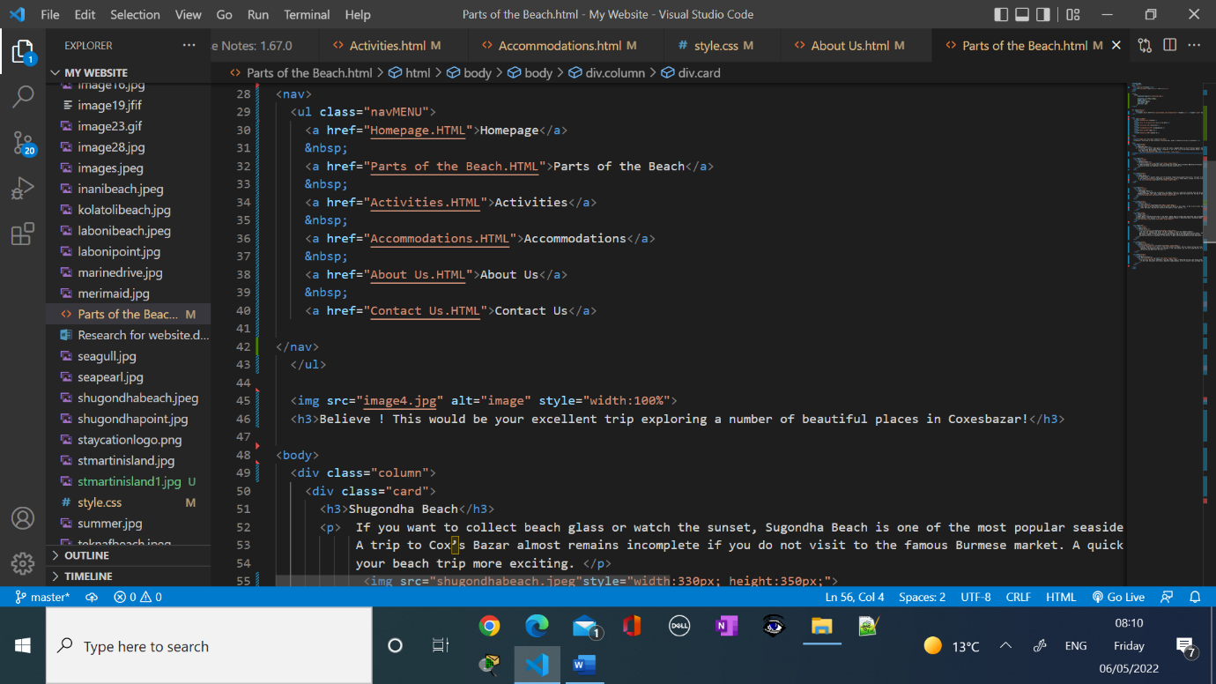

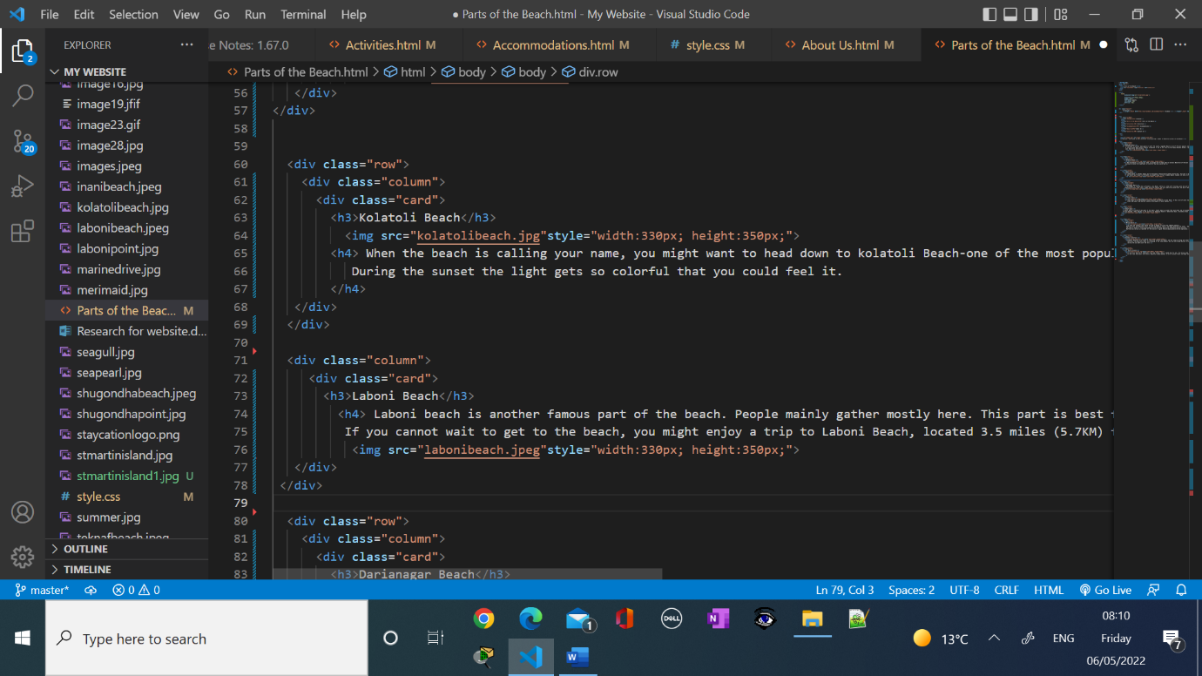

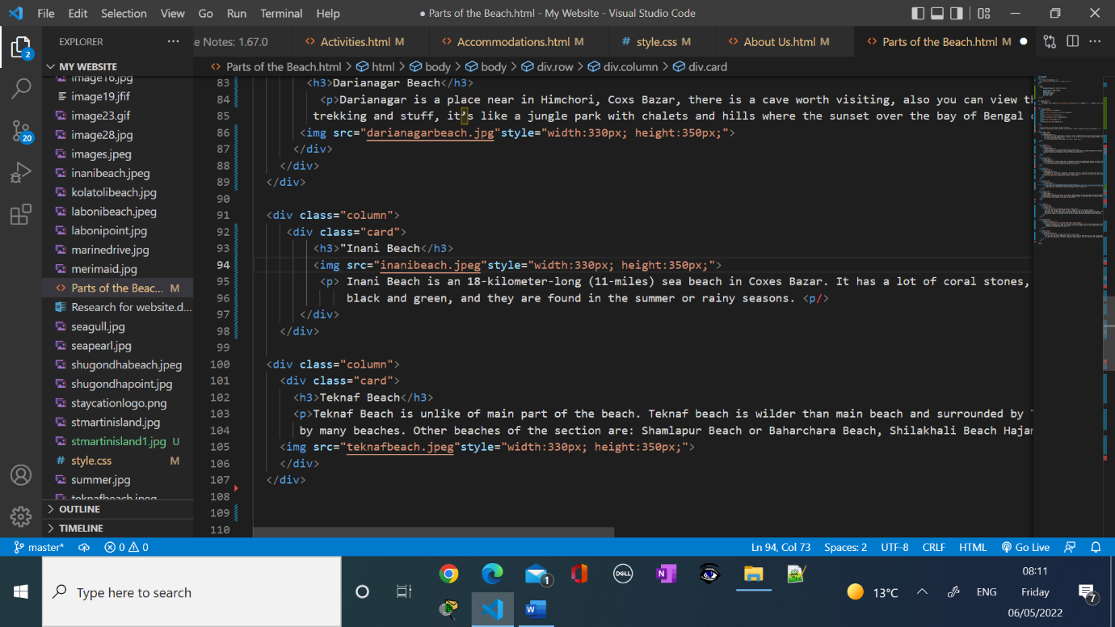

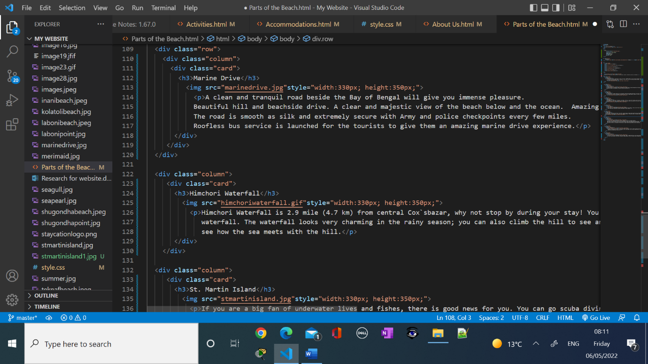

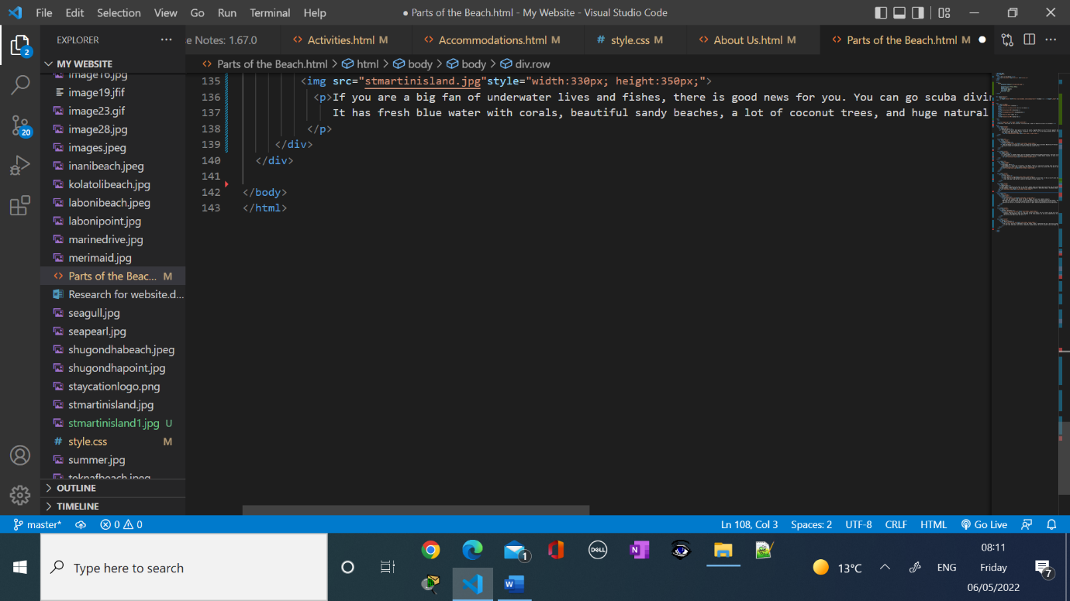

**Screenshots of Activities page:**

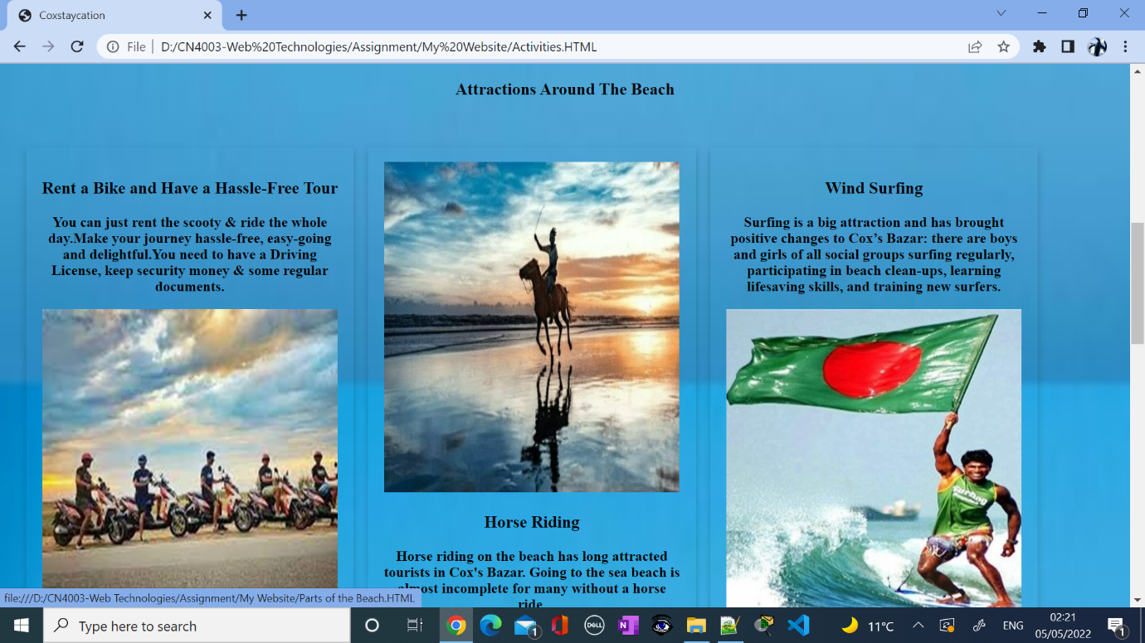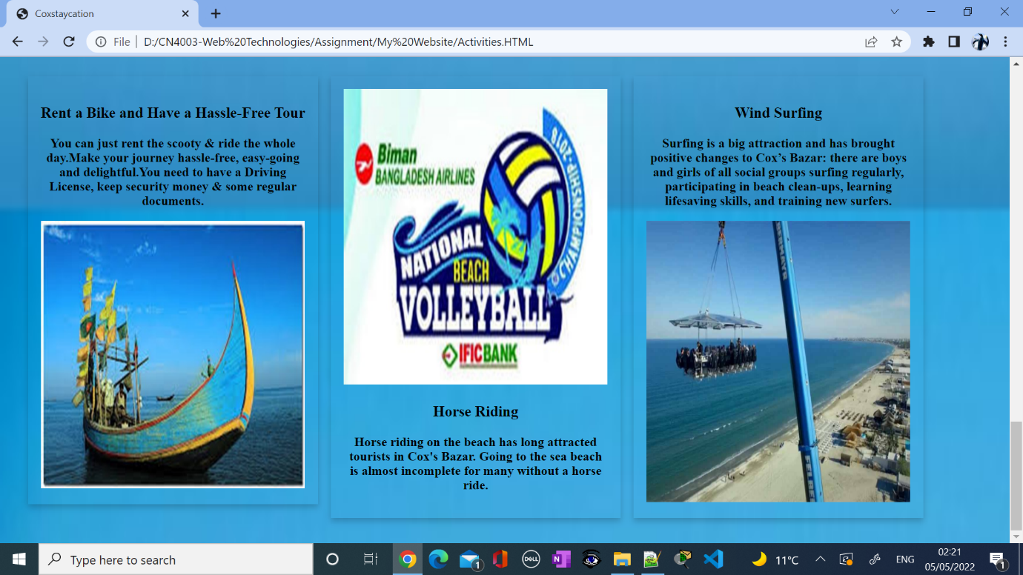

**Screenshots of the codes of Activity Page:**

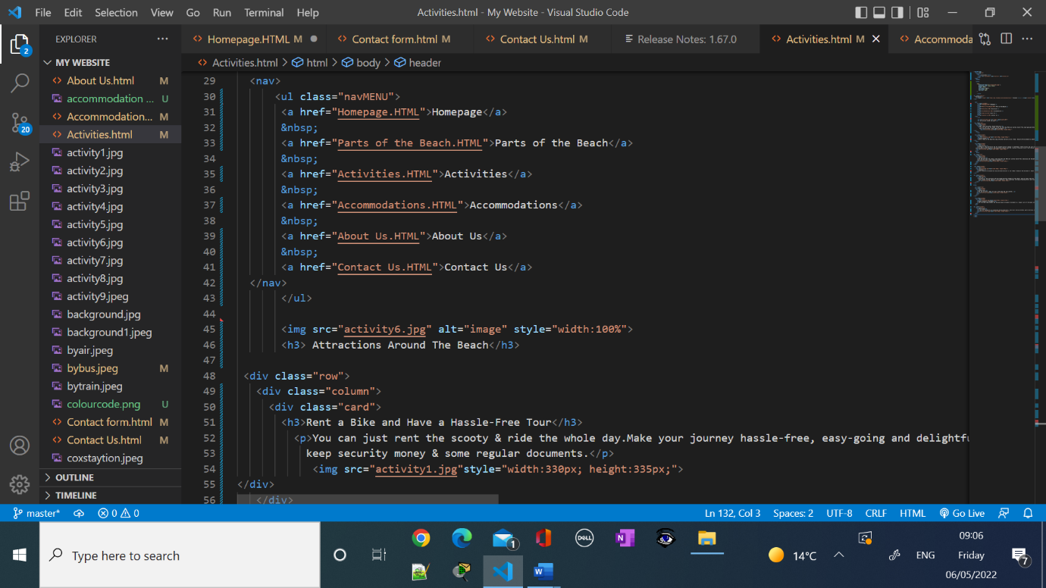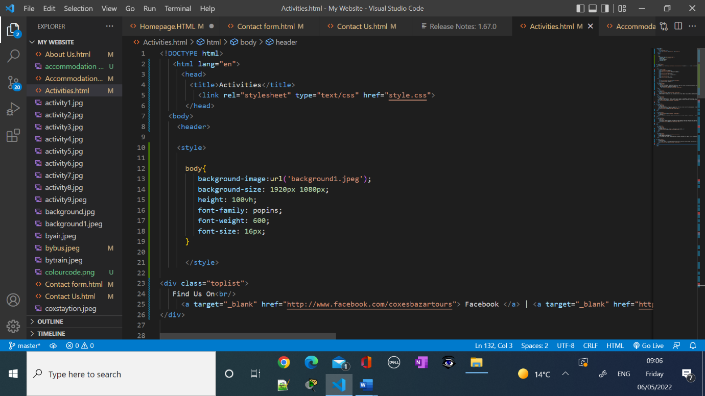 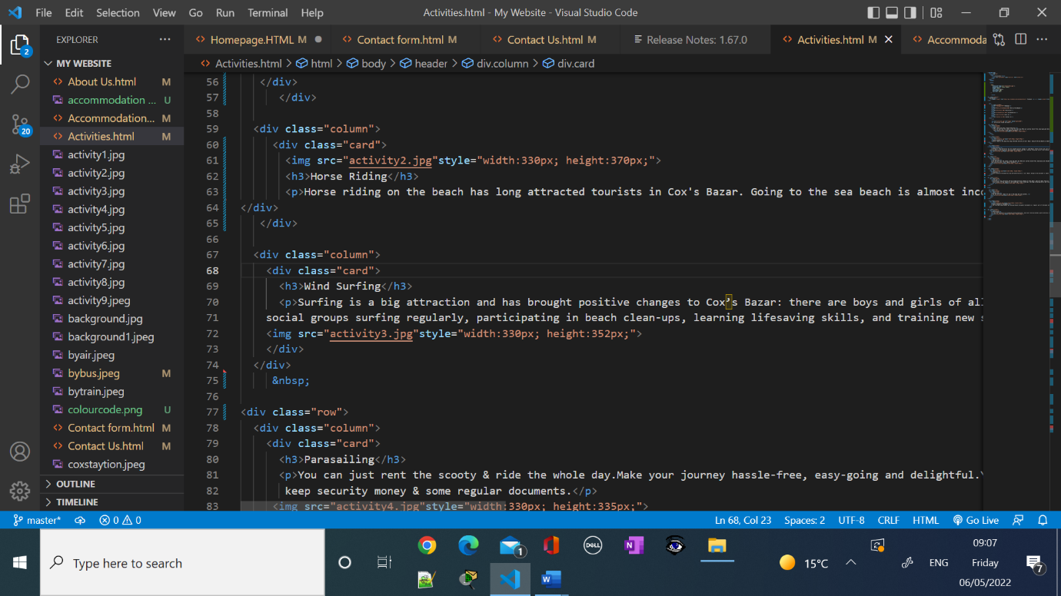

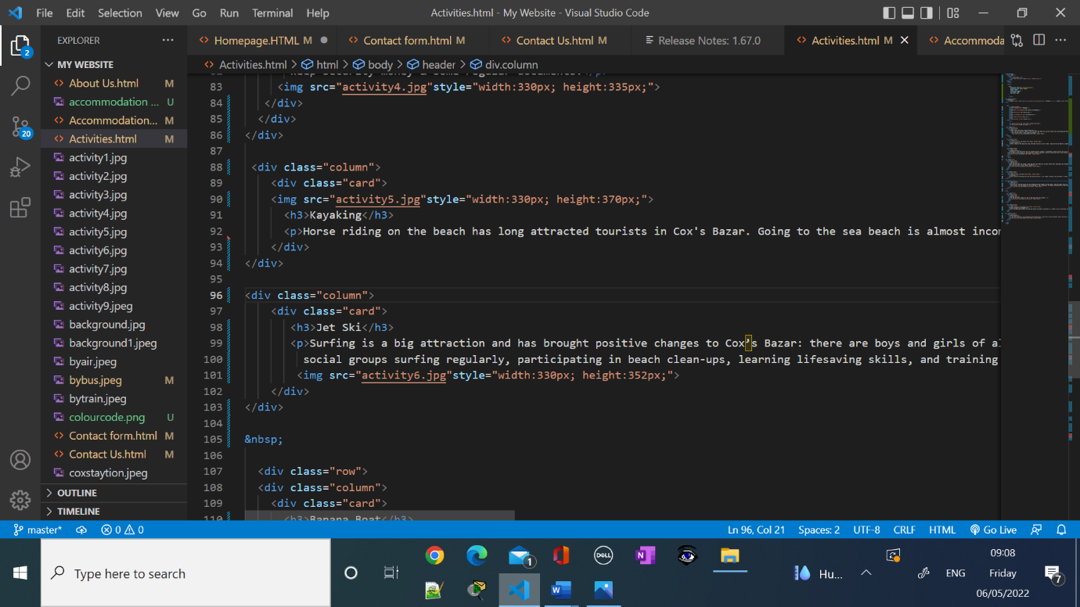 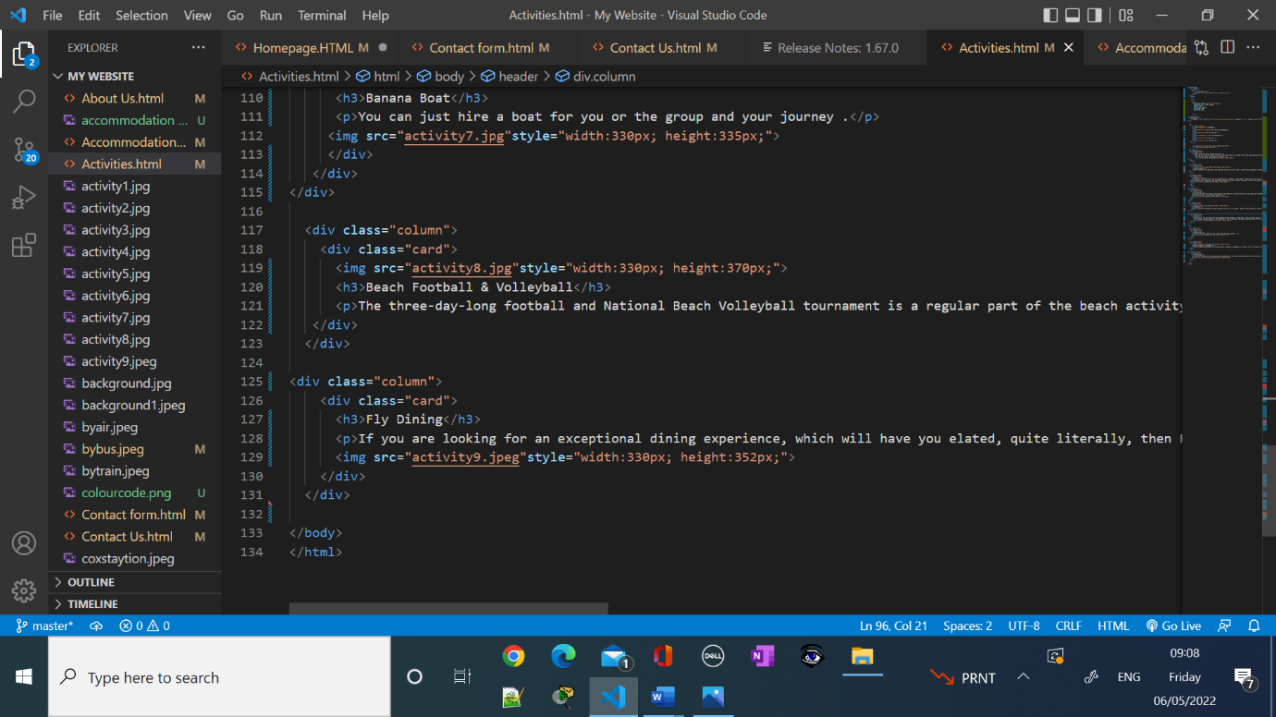

**Screenshots of the Accommodation Page:**



**Screenshots of the Codes of Accommodation Page:**

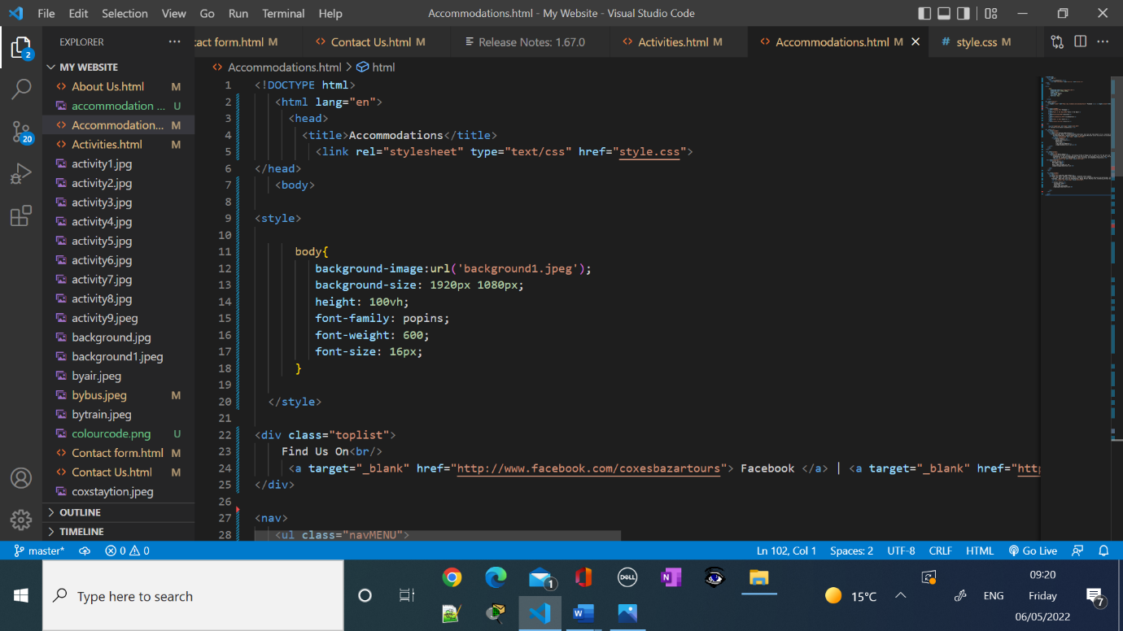

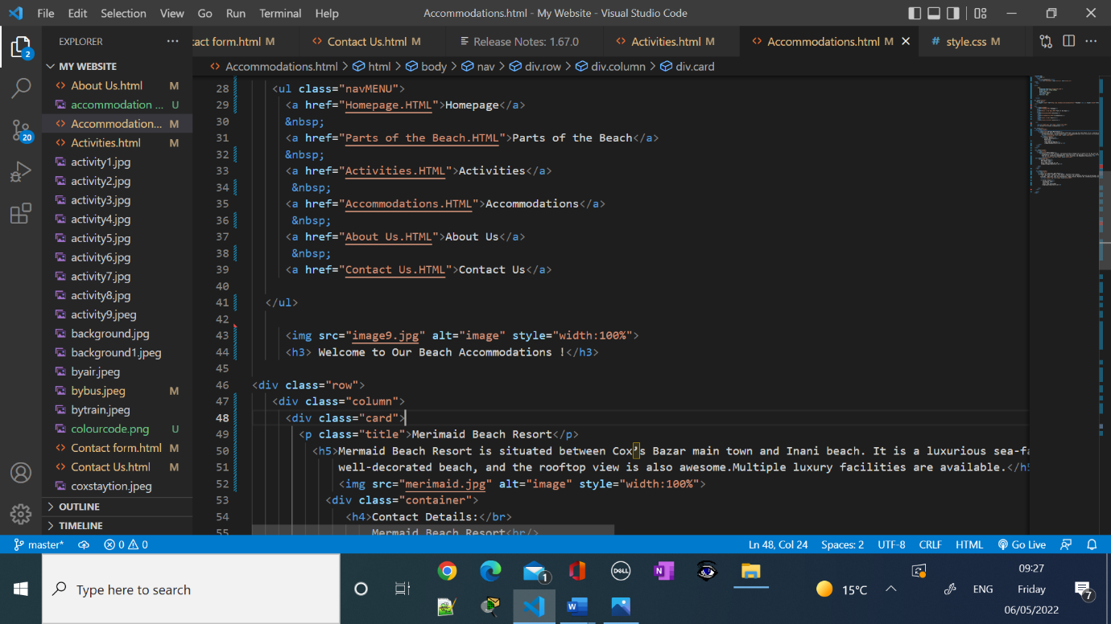 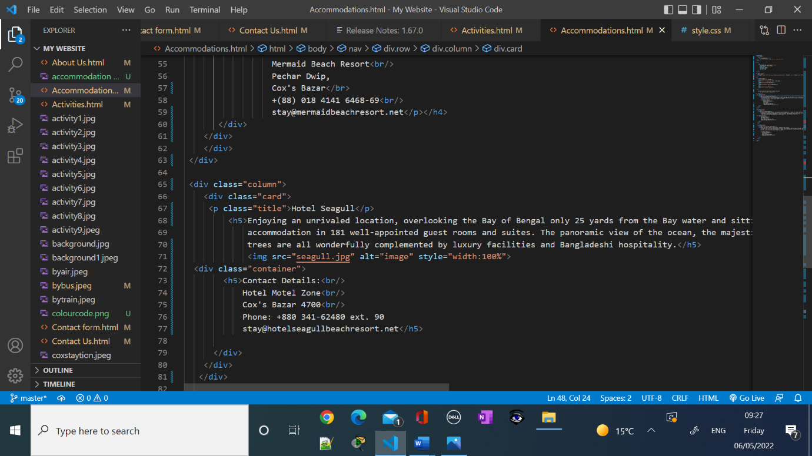

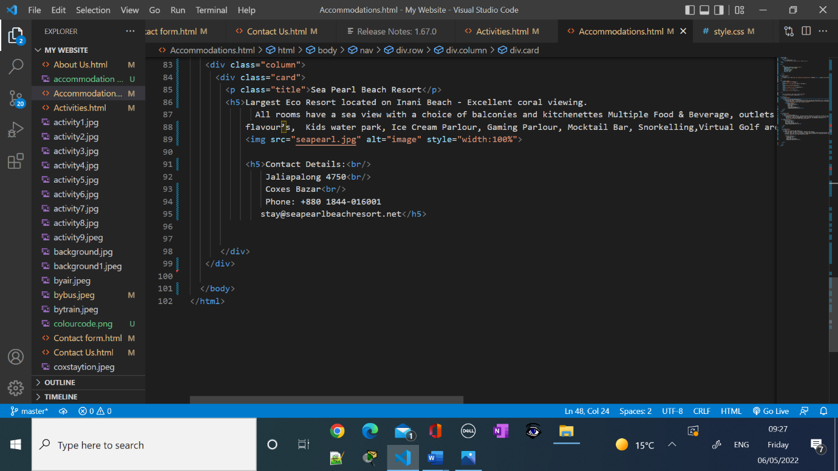

**Screenshots of About Us Page:**



**Screenshots of the codes of Activities Page:**

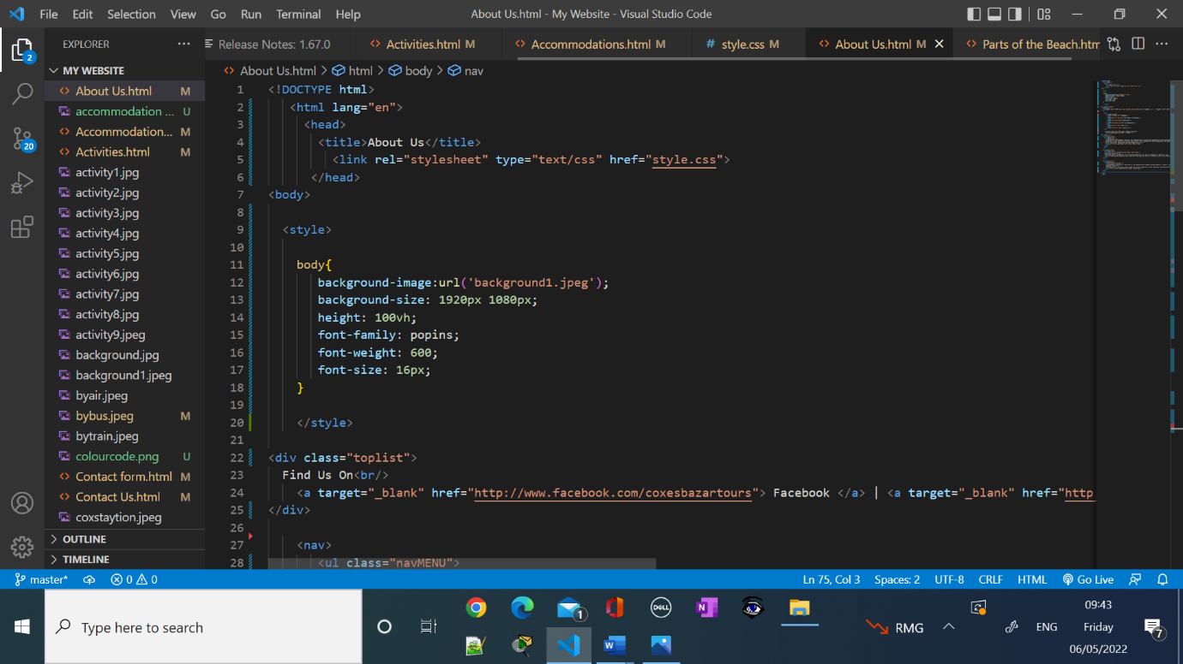 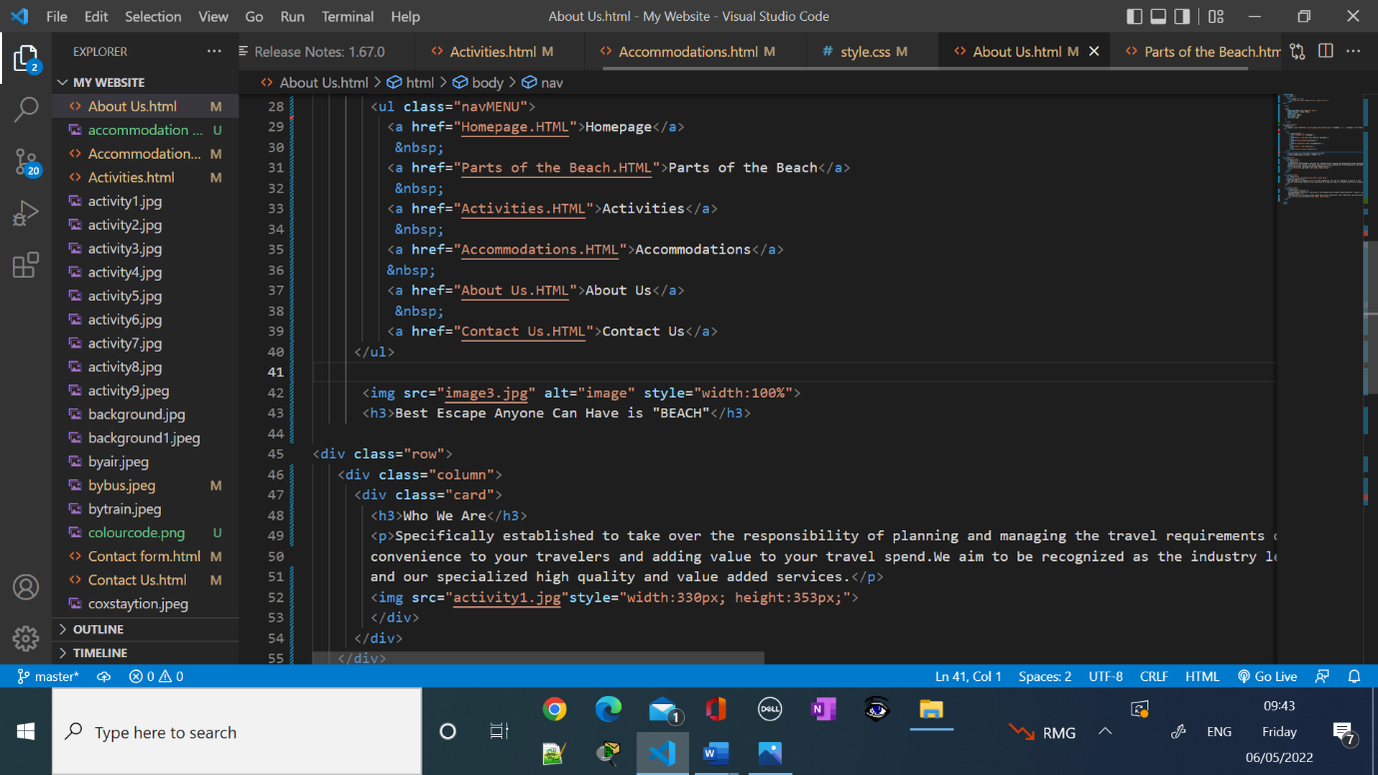 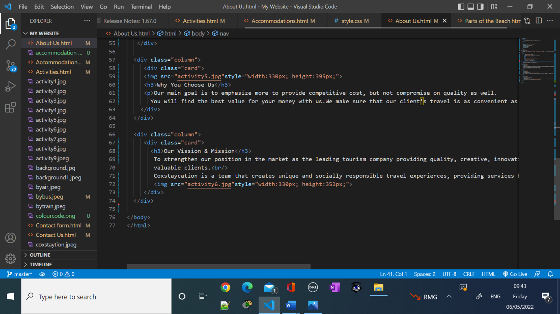

**Screenshots of Contact Us Page:**







**Screenshots of the Codes of Contact Us Page:**

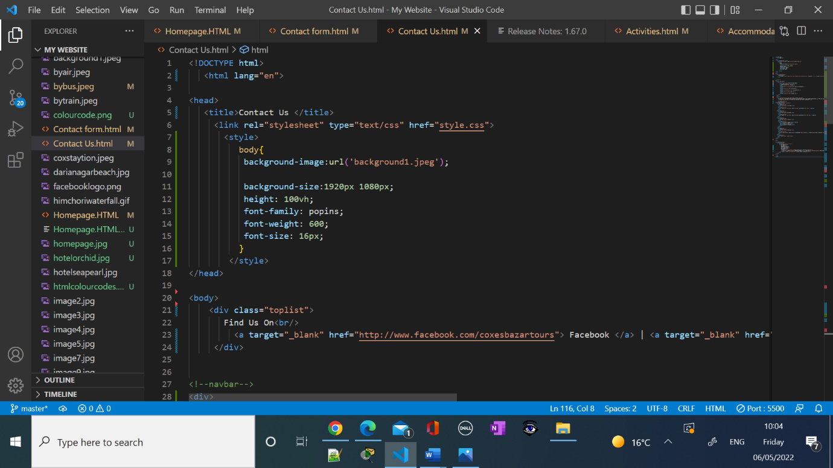 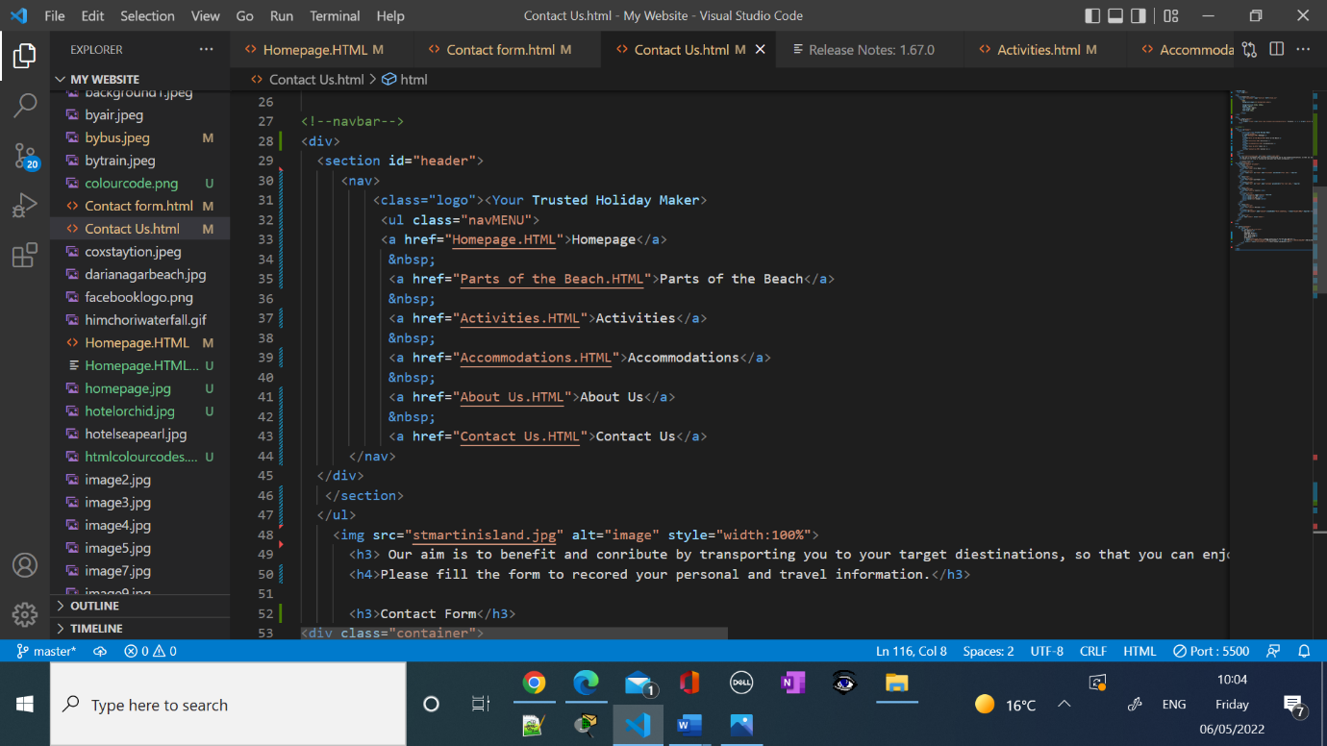

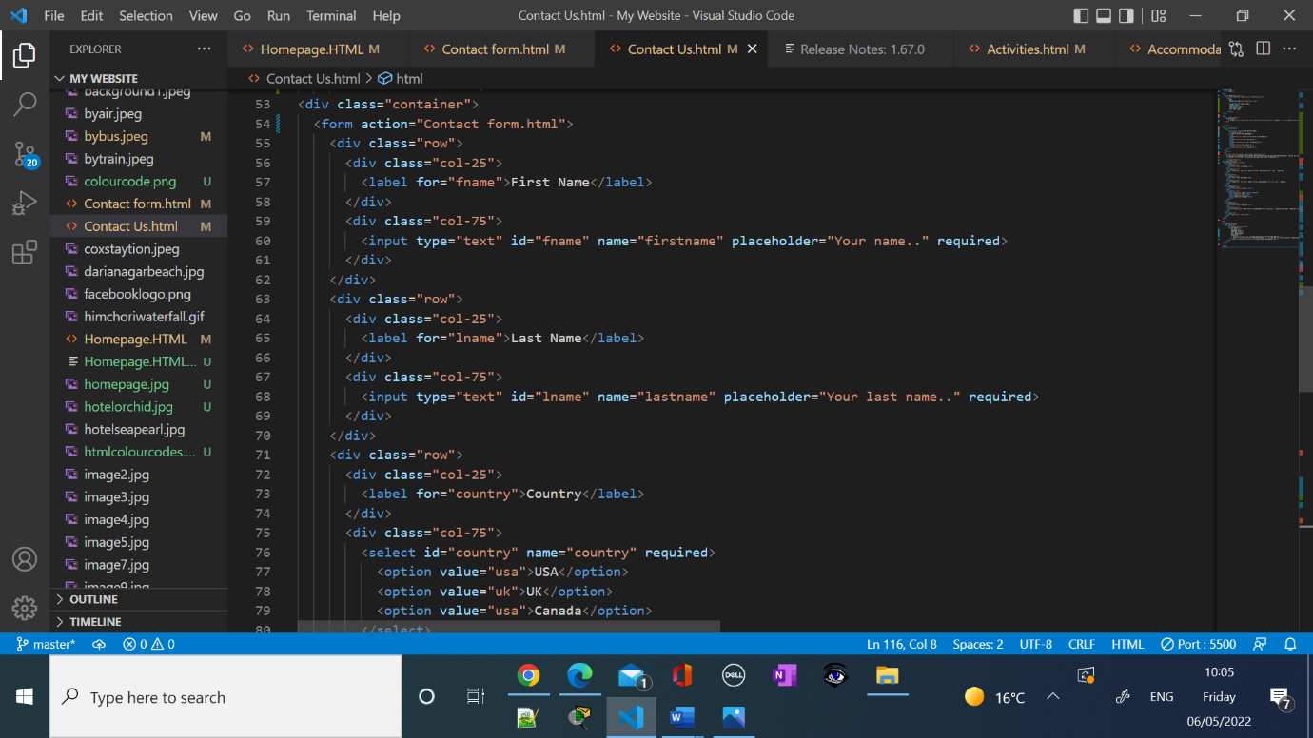

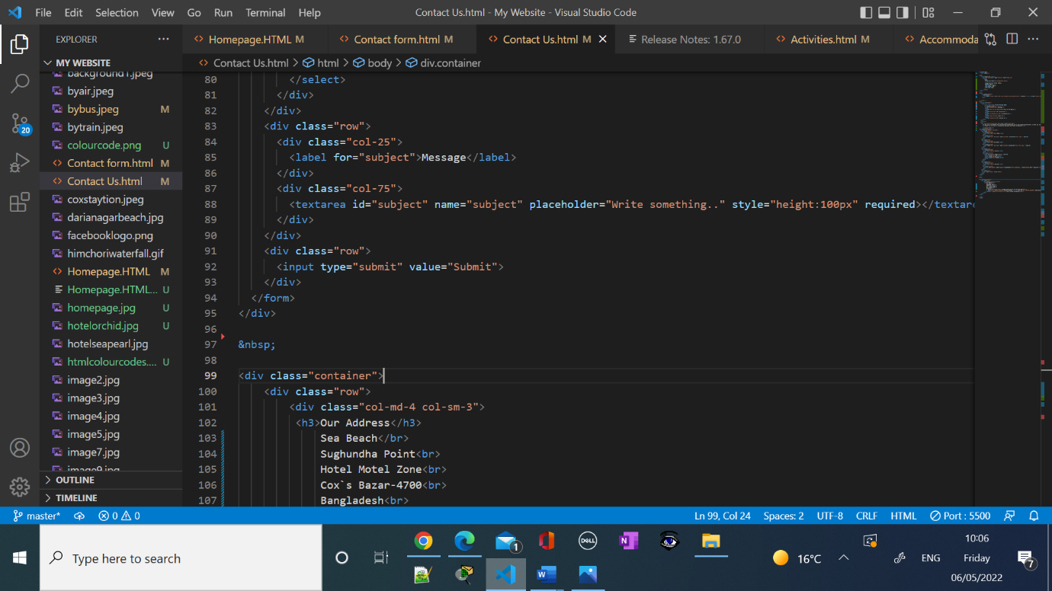

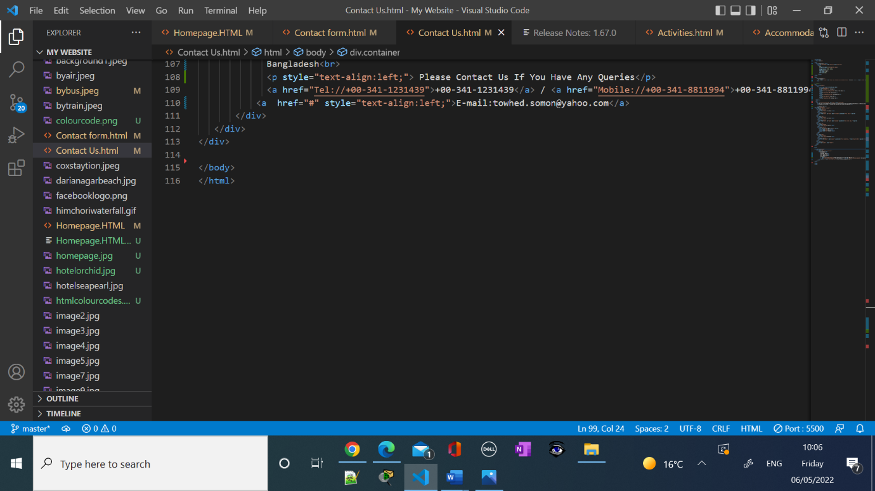

**Screenshots codes of Contact Form:**

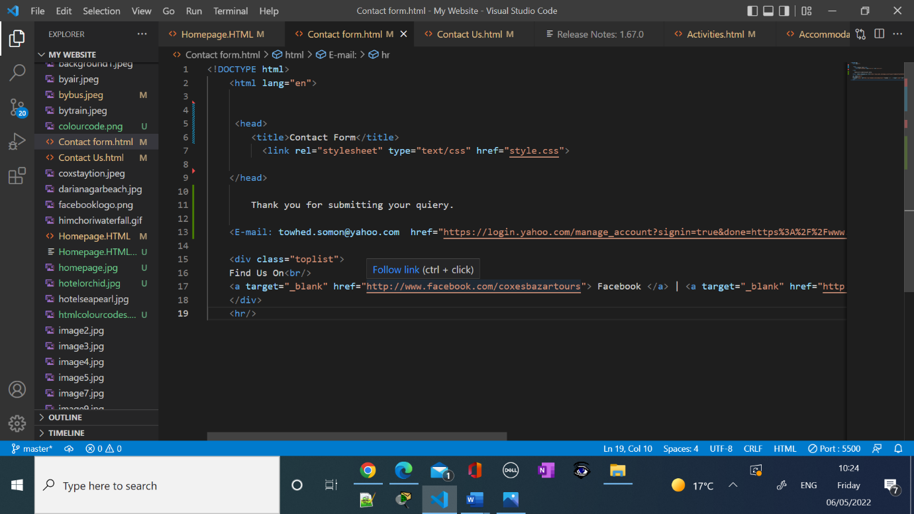

**Screenshots CSS:**

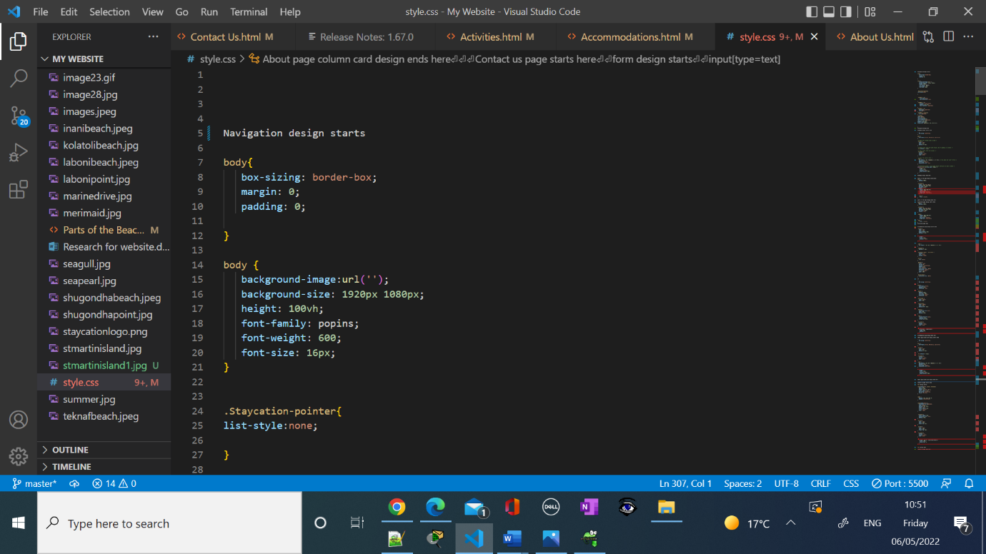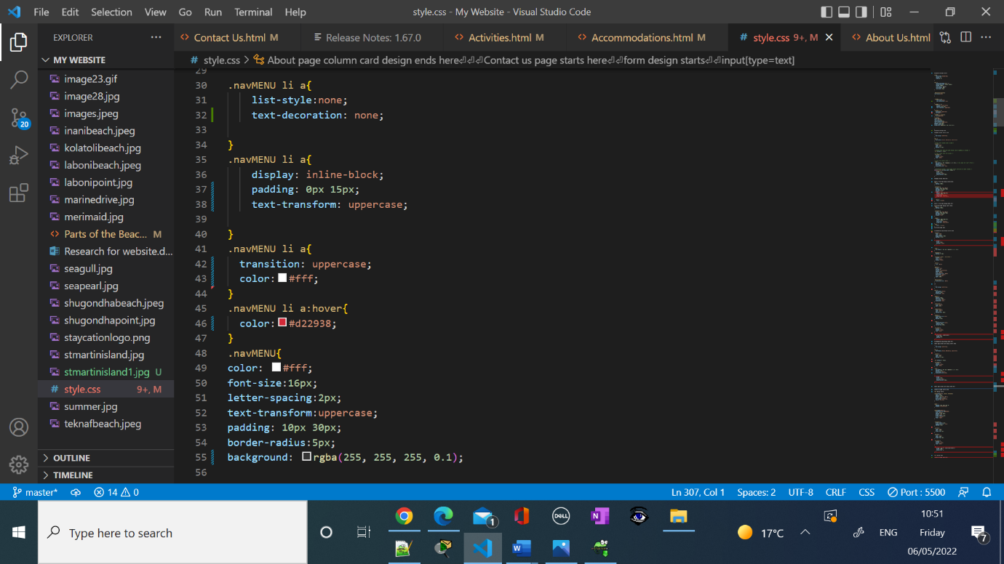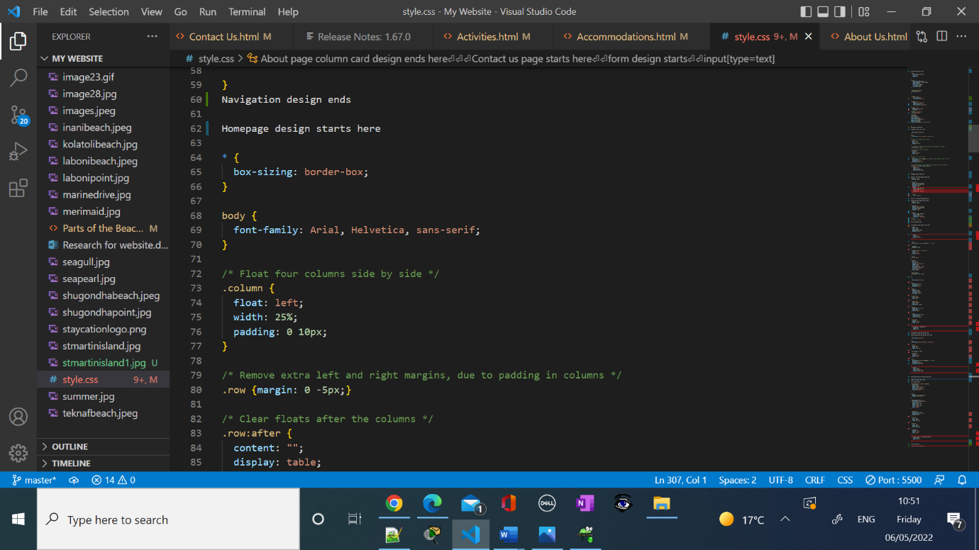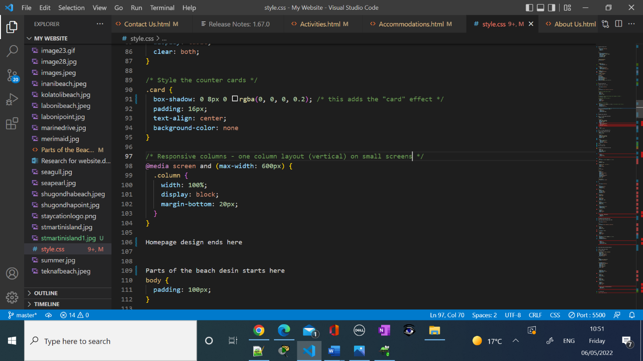

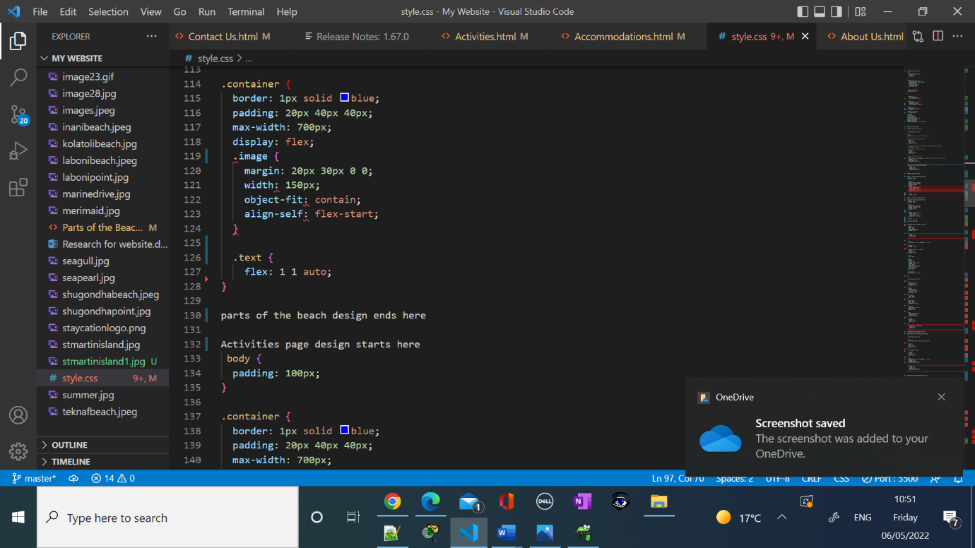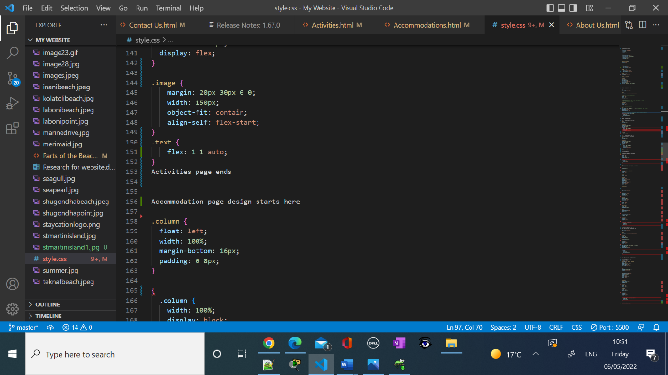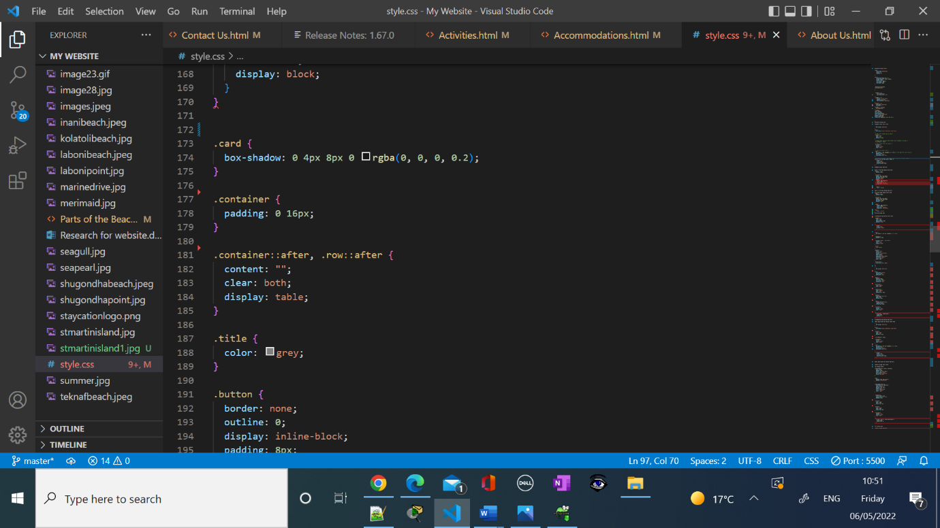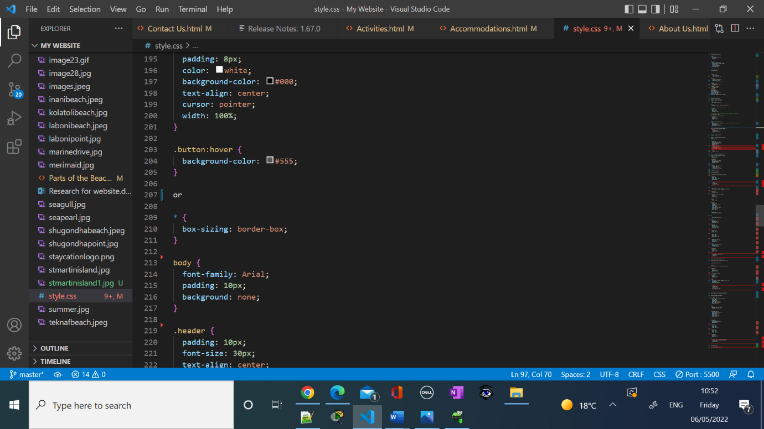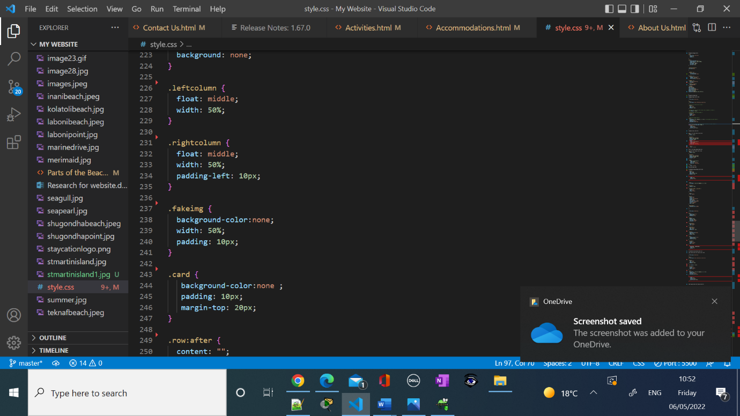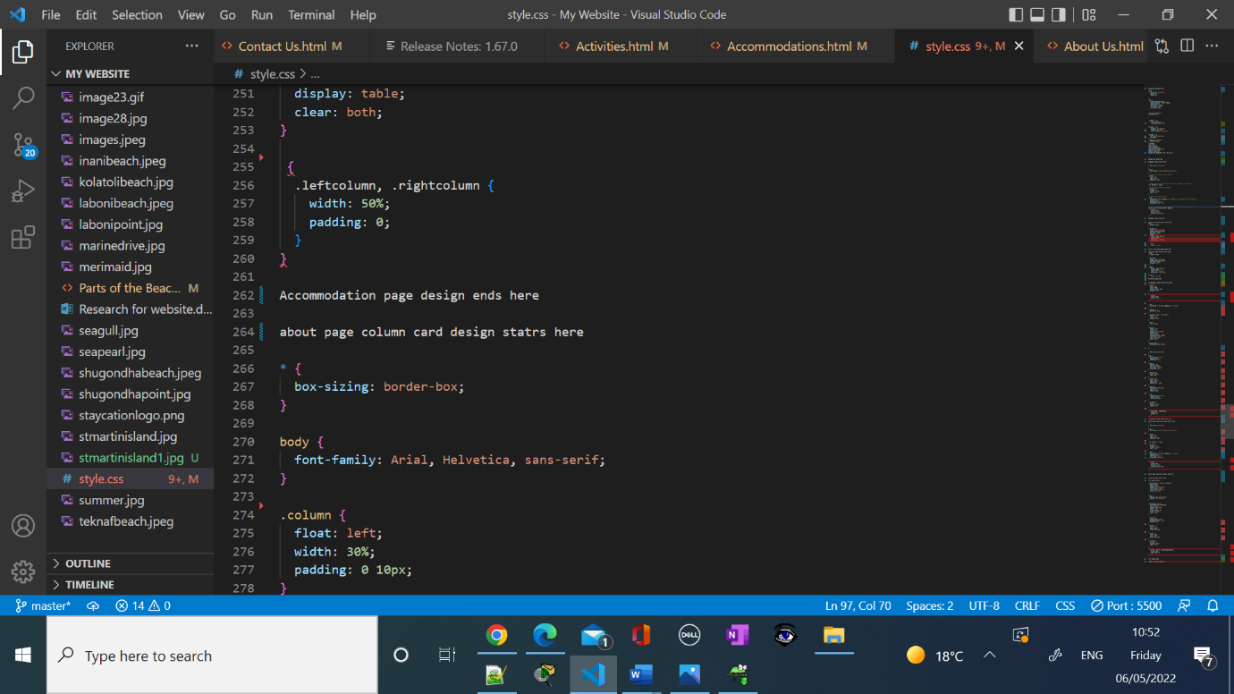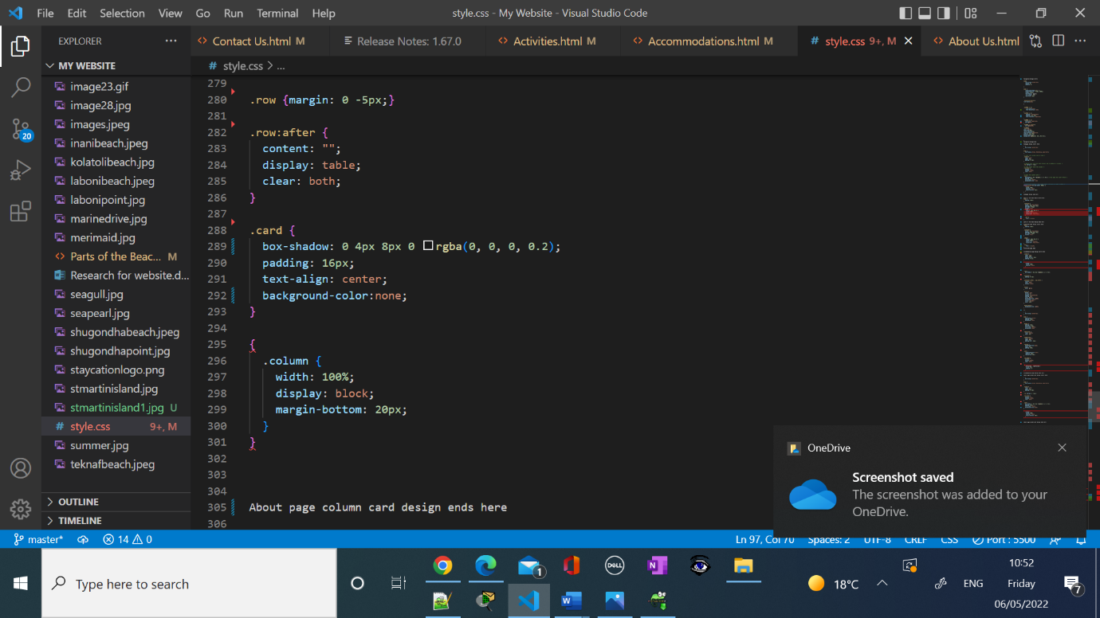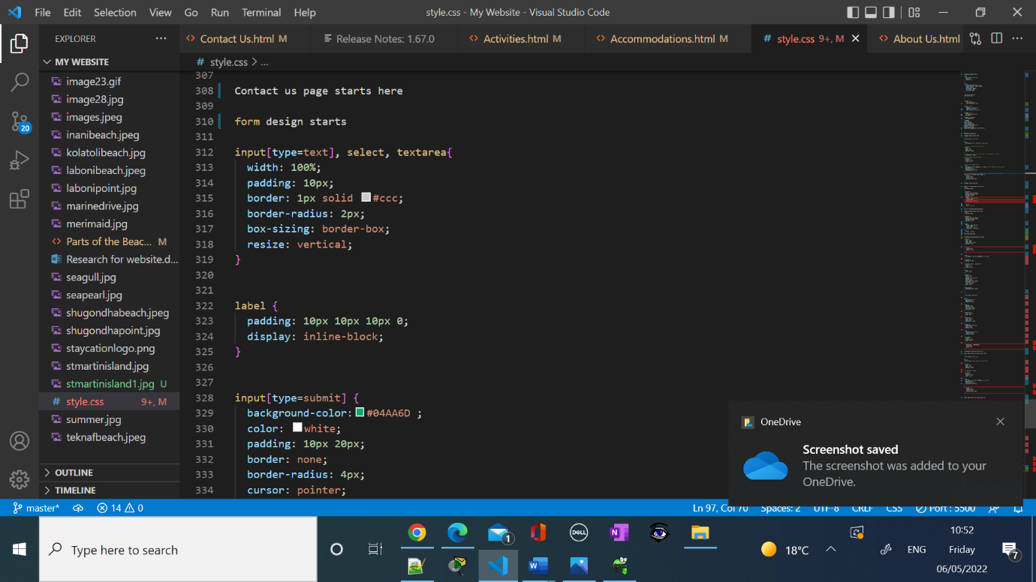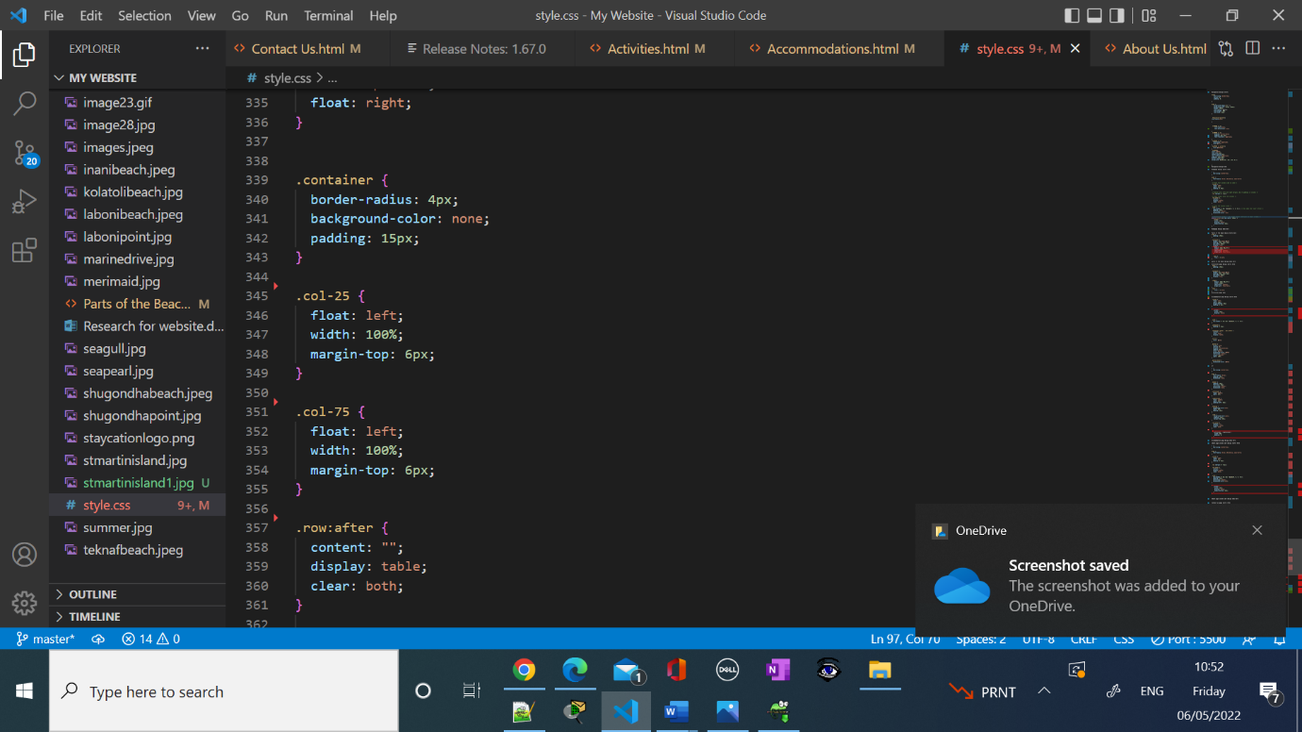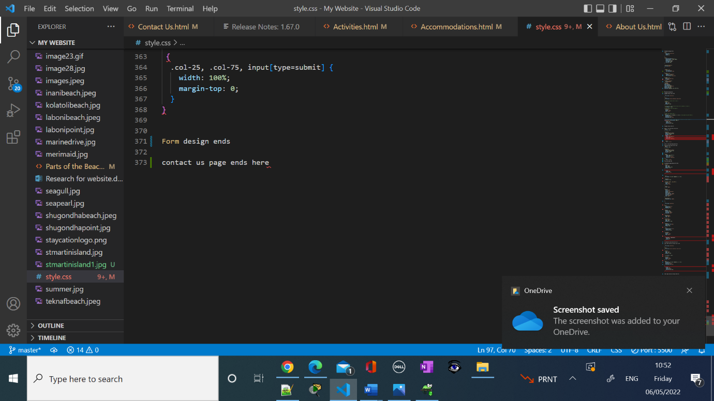

**Screenshot Contact Form:**

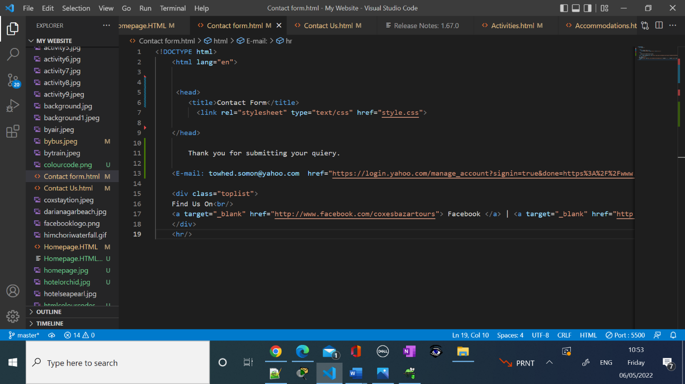

**CSS Validation:**

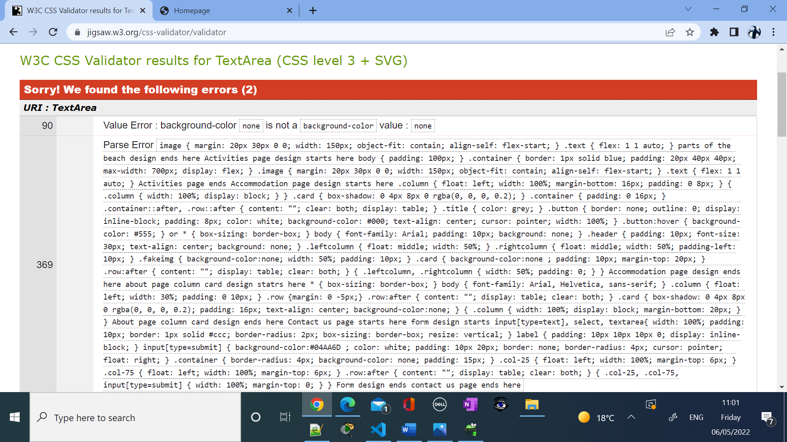

**Assignment End Here.**